Effect of Political Conflict

*Georgian Children’s Perspective and Attitudes Towards Russians*

Irine Osepashvili



Master Thesis

Department of Political Science

UNIVERSITY OF OSLO

13 May 2012

Effect of Political Conflict

*Georgian Children’s Perspective and Attitudes Towards Russians*

© Irine Osepashvili

2012

Effect of Political Conflict. Georgian Children’s Perspective and Attitudes Towards Russians.

Irine Osepashvili

http://www.duo.uio.no/

Print: Reprosentralen, University of Oslo

**Abstract**

There is a risk that historical tensions between Georgia and Russia that recently escalated into actual military violence may have certain effect on people, especially on children who are the most sensitive and vulnerable part of any society. Political animosity can spread at individual level causing prejudice and alienation. Using qualitative methods such as drawings and interviews current study deals with understanding Georgian children’s perspectives and attitudes towards Russians in this situation. Participants of the study are ten children of age 11-14: six - from conflict-zone who directly experienced the war and four - from Tbilisi who know about the war via secondary sources. Although qualitative design reduces chance of generalization, it gives possibility of in-depth look at the problem. Analysis of data showed that majority of participants view Russians negatively – most drawings have violent context and image of Russian is either aggressive or indifferent. However in two cases Russian is viewed as positive and friendly. It is notable that both of these children have Russian acquaintance while the rest do not know any of them personally. On the other hand most participants, who are negatively predisposed towards Russians, distinguish between categories of ‘Russian’ and ‘Russian child’ which is perceived far more positively.

Key words: Georgian children, Russians, children’s perspective, attitudes, prejudice

**Acknowledgements**

Several months ago I came across an entertaining graph in internet visualizing life of a project. Graph is V-shaped following the level of motivation during working on it: at first you are extremely excited with your idea. Soon you realize that it is bit harder than you thought and requires some serious effort. In the middle you will probably face certain difficulties but at final point enthusiasm increases again: you see realistic outcome of work and realize how much you learned during the whole process. Writing thesis can be seen in a similar way, yet without help of supportive people it would be impossible to reach the last stage.

First of all I want to express deepest gratitude to my supervisors. Irene Levin was the one who introduced me to the magic world of children’s drawings - the most interesting part of present research. I am very grateful to her for sharing knowledge and experience with me, for excellent guidance, important advices, encouragement and caring attitude. I gratefully thank Karin Dokken for her enthusiasm to help me, useful feedback and valuable comments. For having such wonderful supervisors I awe my thanks to our program coordinators, especially program manager Tora Skodvin.

I would also like to acknowledge everyone who supported me during the fieldwork: Natia, who shared her experience about Tserovani settlement; Rita, who introduced me to IDP families; headmaster and teachers of Tserovani public school; parents of all participants who were very kind and let me work with their children. My special thanks go to each child for sharing their perspective in such an amazing way; I will never-never forget any of them.

I want to express greatest gratitude to my parents, especially to my dad who offered his help to drive me from Tbilisi to Tserovani whenever I needed, so I never had to worry about distance.

Finally I would like to thank my friends who went through all ups and downs of writing process with me. Without their support everything would be much harder.

All errors and mistakes are only mine.

Irine Osepashvili

**Table of Contents**

List of acronyms XI

1. Introduction 1

1.1. Historical background 3

1.2. Focus and aim of the present research 5

2. Literature review 9

2.1. Definition of prejudice and stereotypes 9

2.2. Theoretical ground for prejudice and stereotypes 11

2.3. Prejudice in children 14

2.4. IDCT and Georgian context 18

3. Method 24

3.1. Overview of qualitative research design 24

3.2. Necessity of visual research techniques 24

3.3. Drawing method 27

3.4. Criteria for recruiting children into research 29

3.5. Participants 30

3.6. Procedure 31

3.7. Ethical issues 32

3.8. Method reflections and complications in collecting sample 35

4. Results 39

* 1. Visual data and analysis 39

4.1.1. (1) Drawings with aggressive content 39

4.1.2. (2) Drawings with non-aggressive content 44

4.2. Identifying Russian person 47

* 1. Readiness for social contact 50

5. Discussion 55

5.1. Brief overview of the results 55

5.2. Linkage between IDCT and gained data 56

* + 1. Identification of Russian person 56

5.2.2. Differentiation between “good” and “bad” Russians 56

5.2.3. Attitudes expressed in visual data 58

5.3. Principal findings of the present study 60

* + 1. Distinguishing between “Russian” and “Russian child”………….. 60

5.3.2. Private experience and influence of SPIRs 64

6. Summary and conclusion 68

References 72

Appendix 1 - Drawings of the participants 78

Appendix 2 - Interview transcripts 89

Appendix 3 – Application and response from the Ministry of Education and Science of Georgia (original and translation) 107

**Tables**

Table 1 - Overall answer of all participants 54

**List of acronyms**

CRRC – Caucasus Research Resource Centre

HFD – Human Figures Drawing procedure

IDCT – Integrative Developmental-Contextual Theory

IDP – Internally Displaced Person/People

PRAM – Preschool Racial Attitude Measure test

SIT – Social Identity Theory

SPIR – Shared Psychological Intergroup Repertoire

1. **Introduction**

It has already been around five years since Russo-Georgian relations became popular subject of discussions at more global level. Tense and complicated situation between these states reached its peak in August 2008 with actual short-time war which left behind lot of victims including internally displaced people (IDPs). Various experts who try to understand the issue usually focus on political or economic aspects of Russo-Georgian relationship with according emphasis on Realpolitik or economy. However increased hostility towards each other at ordinary public level in no matter of less importance and I think seriously influences ongoing processes.

For illustration we can take a look at internet, the cyber space, where different people virtually meet and express own opinions. It is enough just to type only one word “Russian” in Georgian language or “Georgian” in Russian language in Youtube.com search bar and right under the first displayed video we will see endless comments of common users swearing and offending each other in a terrible manner. Others seem to be more polite and satisfy only with accusations of whole nation. Although this is not generalizable data gained by scientific means we can still feel that nation-based aggression comes from ordinary people towards ordinary people. Mutual alienation is going further than political or economic world. Opinions such as “All Russians are…/all Georgians are…” can be regarded as typical stereotypic opinions and the negative meaning, they extremely often have, already points at existing prejudice. According to scientific literature, while stereotypes represent any belief concerning characteristics of particular group, prejudices include particular negative feelings and attitudes generalized on any member of it (Stangor 2000:1).

“…Russians are cruel, misanthropic race… this misanthropy comes from their inferiority complex they can not escape from” “Their only business was drunkenness like pigs” “Did you know, gentlemen, that Russians used to kill own old parents like sheep and eat?” “Russian are Christians but they hate all religions, will it be Christian, Muslim, Buddhist or Jewish.” “This complex, known as inferiority complex, they already have as DNA of evil in the uterus of mother.” “None of the famous Russian public figures was of pure Russian origin.” “They have special hatred towards Georgians” “Even Tamerlane, all Iranian Shahs and Turkish Sultans[1] can not compete with Russia when it comes to hostility towards Georgia.” “…they are waiting for the available moment to visit us from metropolis like in old times and we, enslaved herd of Georgians, meet them with songs”, “Russian only wants Georgian territory and dead or degraded Georgian” – These citations are taken from the article of Georgian academician, publicist and historian Nodar Koberidze, published in Georgian weekly newspaper ‘Saerto Gazeti’ in August 2008, right after the violence between Georgians and Russians started. Although in the beginning he states that article is only based on facts and their analysis, it has nothing to do with them. Author, who displays extremely prejudiced attitude, is offensive and tries to dehumanize whole nation.

Fortunately not everyone in Georgia is that extreme. Attitude research by Caucasus Research Recourse Centre (CRRC) looks more optimistic as it shows that most Georgians still welcome Russians as individuals. Even though 90% of Georgians rates Russia as unfriendly state, 94% are not against friendship with a Russian person or making business with them (91% in 2007, 84% in 2009). According to research conducted in August 2009, with 44% of Georgians approving Georgian woman marrying Russian man, Russians are still the most favorable nation to marry. Researchers admit themselves that such results are “surprisingly positive.” (Gutbort, Papiashvili 2009).

As Russian newspaper Pravda.ru states, according to sociologists from Russian Academy of Sciences positive feelings of common Russians towards Georgia dropped to 8% while negative feelings increased up to 81% after the August conflict (Sudakov 03.12.2008). Though it cannot tell much about personal dislike as in this research attitude was measured towards the state and not towards individuals.

Even if these public opinion surveys are not alarming, individual ideas openly expressed in everyday conversations or in media, and most importantly actual experience of relations show that both societies are under serious threat of tendency generalizing conflict from political field to personal relationships. But when we are talking about actual experience of Russo-Georgian relations, it is crucial to have historical background in mind.

**1.2. Historical Background**

Donald Rayfield, professor at Queen Mary University of London, describes relations between these countries as “love affair gone sour”. I think in fact this “love affair” has always been somewhat sour as complications have been present historically. According to Rayfield, while on one hand Russia provided support for Georgian refugees from Iranian attacks and gave Georgian people access to European education in 17-18-th centuries, on the other hand there were reasons of losing trust in it as well. Tensions started from 1783 when extremely weakened Georgia, surrounded by Turkish and Persian enemies, signed official treaty asking for protection of Russia. Instead of assumed protection Georgia appeared totally annexed: Kingdom was abolished, royal family - exiled and Georgian land, governed by Russian viceroy - officially incorporated in Russian empire. Next to Russian governance model and Russian education, in 1811 Georgian church lost autocephaly and became part of the Russian church. (Slider 1995:159; Rayfield 2007.08.9) Because of too many differences[2] Russification policy appeared very painful for Georgians and was constantly opposed by national rebellions. In 1886 Russian bishop for Georgian church publicly cursed whole Georgian nation at the funeral of school director in Tbilisi, who, Russian as well, was assassinated by Georgian student (Guruli 2011.06.3)

After Bolshevik Revolution, while Russia was in the middle of civil war, Georgia took the chance and in 1918 declared independence, though as soon as in 1921 it was attacked by Red army. National army was defeated and Social-democrat government fled from the country, accordingly new Moscow directed communist government was introduced. It was exactly Soviet period when idea of “one big state” and “brotherhood” of Georgians and Russians was greatly emphasized and due to intense propaganda machine was successfully working for majority of population. Educational curriculum was made up in USSR Ministry of education, maximally repressing subjects that had something in common with national feelings, for example history of USSR was taught very intensively while Georgian history lessons were not even compulsory (Vardosanidze 2008). By 1950s nationalism against Moscow rule anyway emerged in Georgia. After Stalin’s death discontentment also raised between common Russians as they, “aware of Georgian attitudes to them as a nation of male boors and female sluts” (Rayfield 2007.08. 9) started to think that “Georgians had parasitically exploited Soviet tolerance” (Ibid)

Bit by bit nationalism in Georgia increased. In April 1989 peaceful demonstration for restoring Georgian statehood ended tragically with several people killed by Soviet troops. In exactly two years with approval of 98.9% of Georgians parliament passed the declaration of Independence from USSR. New government with President Gamsakhurdia was extremely nationalist using slogan “Georgia for Georgians” and intolerant towards other ethnic minorities referring them as “guests”. Troubles began in regions. During Soviet rule three Georgian provinces were granted autonomy by Moscow - Abkhazia, South Ossetia and Adzharia. In Abkhazia and South Ossetia, both inhabited partly by ethnic minorities, wide-spread inter-ethnic conflicts emerged between separatists and Georgian majority. As Georgian party assumed, separatists were greatly supported by Russia. “South Ossetia is a paradise for racketeers among the Russian army “peacekeepers”, while Abkhazia’s magnificent villas and resorts are coveted by the Russian business and bureaucratic elites. The issue of offering Russian passports to the population of Abkhazia, the Georgians rightly believe, amounts to effective annexation of Georgian territory”, - writes Donald Rayfield in his article later in 2007. As a result these regions reached de-facto independence from Georgia. (Rayfield 2007.08. 9; Slider 1995:166-175) Though from 1992-93 violent war in Abkhazia to 2008 war in South Ossetia, Russia evolved from supporter of separatists to actual opposite side of the conflict against Georgia. Ethnic Georgian population had to flee from South Ossetia as they had to flee from Abkhazia before.

Apart from these issues relationship of Russia and Georgia went through several other relatively minor complications, especially in 2006: such as ban on Georgian wine; Georgian anxiety about discovering Russian spies on Georgian territory which led Russia to imposition of economic sanctions on Georgia, withdrawal of own embassy from Georgia and deportation of Georgian citizens from Russia and so forth.

**1.3 Focus and aim of the present study**

As it can be seen from historical review, relations had never been sweet in political realm; accordingly certain tensions exist when it comes to perceptions and attitudes too. Especially after collapse of Soviet Union and arising Nationalistic government, image of Russian changed from “brother nation” to “invaders” and pre-Soviet story of relations was also remembered. Educational program now emphasized Georgian history, language, literature. Georgian fighters against Russian rule, who were considered as traitors during Soviet time, became heroes. During Shevardnadze period tension calmed a bit, but after Saakashvili took political course towards West, mutual aggression increased again. In both sides it was empowered by massive anti-adversary media propaganda that reached its peak in August 2008.

Negative attitude can be especially apparent between younger people of Georgia, perceiving Russians as aggressive and imperialistic nation. As two generations of common Georgian males fought the war where Russians were indirectly or directly involved as opposite party (Abkhazia and South Ossetia), it makes harder to separate between politics and personal feelings. On the other hand, negative beliefs that are spread in society usually have transmittable character. With a help of different socialization agents, such as media, parents, peers, education, etc. they are passed from one generation to another (Bar-Tal 1996:342,360; Stroebe, Inko 1989). This means that children, who are the most vulnerable representatives of each society, are under serious risk of entering the ‘grown-up world’ already with ready scheme of negative predisposition towards Russian individuals, contributing to intergroup tension even more.

Especially sensitive could be the case of IDP children who actually went through the war themselves. Together with the other sources of learning prejudice, in addition they got quite troublesome own life experience at the very young age. I remember my personal interview with IDP woman with two underage children right after the war in South Ossetia in 2008. “ I am a second time IDP” – she said, - “I was a little girl when we ran away from Sokhumi,[3] I worried because of my teddy bear and asked mom to take it with us, but she cried that it was not an appropriate time for it and did not allow me to do so. I remember myself thinking about that teddy bear permanently. Now when we were escaping from home, this time my daughter asked me if she could take her doll with her. She said it was afraid of being alone. And I let her to take it.” As we can see even from this example, kids are remarkably impressionable compared to adults and when society already gives them ready answers who should be blamed for their tragedy, risk of arising prejudices increases.

Children, especially these children, are part of the conflict and it would not be reasonable to exclude their perspective at all. Their attitudes and perceptions towards Russians should be studied carefully and taken into account as they are Georgia’s future generation who will soon be leaders and actors of all political and social processes themselves. Understanding them now in sensitive period and further constructive work can avoid forming warmonger society in the future. Filling the knowledge gap about children’s view can help to reconsider all those mediums from which they get information, will it be schoolbooks, media and so forth. There can be necessity of developing certain programs and projects aimed to reduce negative stereotypes, teach them to focus on individuals, etc. At the same time special attention should be given to IDP children who are left with traumatized memory of war and Russian soldiers. Because of these reasons I want to take my part in increasing knowledge about the issue and understanding Georgian children’s attitudes and feelings towards Russians at deeper level. The research aims to answer following questions:

**How do Georgian children from conflict and conflict-free zones look upon Russians?**

* **What is special about their perspectives?**
* **Do they display prejudice?**

Of course topic needs to be researched more and at bigger samples so that there was ability of generalization. I think this particular study can provide good basis for further more quantitatively oriented researches as well.

In the next chapter I will discuss general theoretical background of prejudice, specificity of prejudice in children and children in conflict situation. Chapter 3 is a methodological part of the research: here I will talk about qualitative method; common techniques of getting information from children with the help of visual instruments; and drawing method, present study is based on; also about sample criteria, participants and method reflection. Chapter 4 focuses on gained data, which will be analyzed in Chapter 5. Results of the research will be summed up in the last chapter.

**2. Literature review**

**2.1. Definition of prejudice and stereotypes**

Stereotypes and prejudice stand as one of the most interesting scientific problems in the field of psychology. Although definitions vary a little bit and there is not one unique formula to define these terms exactly, all sources agree on certain points that characterize prejudice, as well as stereotypes. To make clear distinctions between these terms it is necessary to refer to them initially separately.

Allport, one of the most influential researchers of prejudice, defines it as “an avertive or hostile attitude toward a person who belongs to a group, simply because he belongs to that group and is therefore presumed to have the objectionable qualities ascribed to the group.” So prejudice is not just a simple dislike, together with negative attitude there should exist overgeneralized belief. People, who are prejudiced, tend to rationalize their attitude by ascribing unfavorable traits to specific target group such as lazy, aggressive, intellectually inferior and so forth. (Allport 1958:8,12,83). Generally, prejudice, as any other attitude, consists of three basic components: cognitive (irrational belief about concrete group), affective (dislike), and conative (behavioral predisposition towards discrimination) (Dovidio et al 1996:278; Stroebe, Insko 1989:8).

On the other hand, although stereotypes also represent overgeneralized beliefs towards particular group, they do not necessarily have to be negative, for example such as wide spread association between Asians and being good at math, Germans and punctuality, librarians and introversion, etc. Basic difference is that unlike prejudice, stereotypes do not involve more than opinions or beliefs, they do not have emotional component, so we cannot consider them as attitudes. (Allport 1958:187; Stangor 2000:8; Stroebe, Insko 1989:8 )

Both stereotypes and prejudices are result of categorical thinking. As world around us is extremely complex to deal with, our minds tend to simplify it by categorizing things. According to Allport prejudgments associated with categories are normal and natural human tendency but at the same time often exactly they are the ones responsible for biased and faulty understanding of social world, especially when strong negative emotions get involved in mere categorization process and we get highly hostile attitude as a result. Although stereotypes do not always lead to prejudice, there are strong links between them. As researches show, highly prejudiced people are more likely to activate stereotypes towards concrete social groups than low-prejudiced people, so when such person encounters a particular group member, automatically activated negative stereotypes heavily influence their judgment. Another misfortune is that stereotypes as well as prejudices are rigid and resistant to change. People are selective in perceiving environment, encoding and processing wide range of information so that it was consistent with already existing beliefs (Locke, Johnston 2001: 113-120, Allport 1958:17-22, Dovidio et al 1996:279 ). Biased perception can often be associated with tendency of in-group favoritism (when one considers own group as better than out-groups), out-group homogeneity (outside members look more alike than in-groups), assimilation (minimizing differences between categories) and contrast (exaggerating differences between categories) that also work in favor of stereotypes and prejudices (Plous 2003: 5-12)

**2.2. Theoretical ground for prejudice and stereotypes**

Scientific literature offers various models and theories to explain origins of prejudice and stereotypes, and even though each is looking at the problem from a very different perspective, basically they can be grouped under two broad approaches: individual and socio-cultural theories. While individual approach focuses on personal motives and cognitive aspects, socio-cultural approach has to do with cultural and society influence. Obviously both have their strengths and limitations and taken alone are extremely one-sided.

Individual approach includes cognitive and psychodynamic theories. Cognitive theories emphasize the role of “cognitively mean” individual who needs to apply abstract knowledge structures such as group schemas, prototypes and exemplars to simplify complex reality while processing information. On the other hand, psychodynamic theories take into account individual motives and traits, such as internal conflict or frustration of a particular person, when concrete low status group acquires function of scapegoat; or authoritarian personality type who is more prone to develop generalized hostile attitude (Stroebe, Insko 1989:17-30; Stangor, Schaller 1996:5-10, 14-16). However, as current research basically deals with prejudice as culturally shared phenomenon in the context of Russo-Georgian political tensions, I will not discuss each theory in details.

While individualistic theories mostly consider direct contact with particular group members as origin of stereotypes, social-cultural theories focus on contagious and reproductive character of such prejudgments from one individual or one generation to another. Society is seen as storage of knowledge where stereotypes exist as public information about particular group. This information is spread among individuals and passed to new generation with the help of socialization agents: parents, teachers, peers, political or religious leaders and most importantly, mass media. Culture already provides ready answers to all life problems; on the other hand when particular stereotype or prejudice is widely spread in given society, it becomes kind of social norm and it is hard to violate it at individual level because of conformity pressure. From this aspect the more conformist an individual is towards social norms generally, the more s/he is prone to show prejudices. Pressure keeps individuals in line - group preferences must be his preferences, group enemies - his enemies. (Allport 1958:38, 271; Stangor, Schaller 1996:10-14, 16-18; Stroebe, Insko 1989:13-17)

As current research basically deals with group-based prejudices that have more socio-cultural origins rather than individual ones, it is important to look deeper into socio-cultural approach which itself consists of two sub-groups: Conflict theories and Social learning theory. Conflict theories include Realistic conflict theory and Social identity theory (SIT). According to Realistic Conflict theory, out-group prejudices are result of intergroup competition for limited resources. Sherif, the social psychologist this theory is associated with, conducted series of experiments on 11 year old boys at summer camp of Oklahoma, Robber’s Cave. Children were divided into two formal groups with different names and symbolic attributes. Competitive situation was created so that in case of failure in gaining resources only opposite group could be blamed. (Sherif&Sherif 1953: 239-240) After number of experiments Sherif finally concluded about two main arguments of Realistic conflict theory:

1. “When groups engage in reciprocally competitive and frustrating activities, such as victory or gain of a desired goal by one group results in a defeat or loss for the other group, unfavorable attitudes come into use in relation to the out-group and its members. In time, these unfavorable stereotypes are standardized in a group, placing the out-group at a prejudicial distance (proportional to the degree of negative relations between them).
2. Concomitant with the rise of mutually prejudicial attitudes between groups, self-glorifying or self-justifying attitudes towards the in-group are strengthened. The performance of the out-group is deprecated and the moves of the out-group and its members are perceived in a suspicious light.” (Sherif 1962:10-11)

According to Social identity theory competition can take place not only for scarce physical resources but for social resources, status and prestige, as well. Tajfel defines social identity as “knowledge that (one) belongs to a certain group together with some emotional and value significance.” Individuals search for maintaining positive self-identity and in order to do this they try to distinguish own social group from others by raising its status and believing it is better. Such positive distinctiveness is created and reinforced by different means like social myths, actions and movements. Tajfel introduced “minimal group paradigm”, which assumes that simple categorization of individuals into different groups is already enough condition to produce intergroup prejudices. (Tajfel, Forgas 2000:54-55; Stroebe, Insko 1989:14-15; Bigler et al 1997: 530; Plous 2002:13-15)

On the other hand Social learning theory focuses on role of observation and imitation. According to it stereotypes and prejudices are formed by direct observation of target group. Often how it is seen can depend on its long-time limited social role in society, for example “housewife” stereotypes of woman. Basic emphasis is made on socialization agents: family, friends, media, literature, drama, films, etc. (Stroebe, Insko 1989:15-17; Stangor, Schaller 1996:61). These agents carry special threat to pass negative beliefs to young generation.

In present case my focus of attention is culturally spread prejudice, rather than individual biases of one particular person. Prejudice is seen as a product of tense political relations between Russia and Georgia that is greatly strengthened by various social agents. Therefore compared to individual theories socio-cultural approach can provide better theoretical framework for explaining this situation but still not the best. For full understanding it is important to look for more integrative theory that does not undermine individual factors and at the same time is applicable for children.

**2.3. Prejudice in children**

As we see there is no theory that captures the problem overall, the strength of one is a weakness of another. Trouble of socio-cultural approach is that it ignores role of cognition and individual differences while person-oriented theories do not care about society influence. On the other hand my interest lies in children and even in case of existence of one ideal theory for adults, still there is a threat that it will not work for kids. We cannot look at children as small adults or simple imitators, differences are basically of qualitative than quantitative character. It is crucial that child’s cognitive development at certain age was taken into account.

According to Aboud, certain components of prejudice, as we see them in adults, are too complex for children. While, thanks to earlier development of preferences, evaluation and affect, we can clearly observe negative attitude in kids, problem emerges when it comes to generalization and categorization. Young children do not have cognitive ability to categorize accurately and compared to adults they tend to notice more differences among people that are relatively unessential; also their prejudice can lack cohesiveness and consistency (Aboud 1988: 4-6)

Although prejudices in children are not researched as much, there are certain theories that try to explain their specific character. Basically as in case of adults there are two groups of theories that emphasize either personal emotional maladjustment or social factors and they too suffer from one-sidedness.

First approach concentrates on role of child’s inner frustration and aggression due to repressive and harsh upbringing. Failure in finding alternative ways to express aggression leads to direct it towards people who lack authority and power. Although this point of view, heavily influenced by Freudian thinking, can be valid in certain individual occasions, it can say nothing about group spread prejudice. (Aboud 1988:20-21; Nesdale 1999)

On the other hand social reflection theories see child as mere imitator of surrounding socialization agents, where parents are most powerful sources of influence. Young children see parents as omnipotent; they identify with or just want to please them by acting in a similar way. Parents either train their sons and daughters directly, either create prejudiced atmosphere in which child observes and imitates their verbal or nonverbal behaviors.

In context of this approach Allport distinguished three stages that children are going through:

Stage I – Pregenaralized learning that lasts till age 6 when child lives in reality of “what is here and now”. For example, 5 year old kid can understand own membership of certain group but he cannot tell what is the difference between groups. Although from the very little age he is already presented to language tags that adults use for categorization, abstraction and generalization when cognitively he is not ready for it yet. These tags prepare kid for prejudices.

Stage II is stage of total rejection. Once child is unable of generalizing by essential traits, as creates category, overgeneralizes and rejects everybody. This tendency reaches its ethnocentric peak at puberty and lasts about 6-8 years.

Stage III is differentiation stage, when prejudices get modified and less total approximately from 12-th grade. (Allport 1958:28, 277, 282-283, 293-294; Aboud 1988:18-19; Nesdale 1999)

However number of researches show low or nonexistent correlation between parents and children’s attitudes (Bird et al, 1952; Frankel-Brunswik & Havel 1953, Aboud & Doyle 1996b as cited in Nesdale 2001:65 ). It means that children should not be seen as passive imitators and clean boards on which parents write whatever they want.

In contrast, Aboud offers socio-cognitive theory that takes into account level of age development in relation of two overlapping sequences. First sequence focuses on what dominates child’s experience at particular age. As he is growing up, domination of affective state is changing into domination of perceptions and then cognitions. Second sequence emphasizes focus of child’s attention from self to groups and finally to individuals. Consequently the very young age is characterized by fear of unknown and attachment to familiar and later preference of similar and rejection of dissimilar becomes dominant. Finally by age of 7 children begin to understand individual qualities of people; in addition by this time they become less and less egocentric. Prejudice is most active from the age of 4 to 7. After 7 they decline themselves. Therefore according to Aboud, prejudice is inevitable in children because it is part of their cognitive development, they will always show biases regardless their social background. (Aboud 1988:22-27,30,43-44,125-125; Nesdale 1999, Nesdale 2001: 66-68)

Socio-cognitive theory is very attentive towards cognitive and developmental issues, but again it faces the same old problem: now it leaves child’s social context out. Also it assumes that all the prejudices should diminish through the age that often does not correspond to reality.

The most comprehensive look at the problem takes Nesdales’s Developmental Social Identity theory as it equally emphasizes social environment and individual developmental process. As we can assume from the name, theory is heavily based on already discussed Social Identity Theory (SIT) that focuses on person’s desire to identify with own group and positively distinguish it from the other ones in order to raise own self-esteem. So people see outside world from the perspective of own group, which gives them knowledge about out-groups and about relationship between own and other groups as well. Nesdale draws his theory on empirical data which suggests that SIT can be generalized on children as well. As early as at age 3 children can already make intergroup comparisons and prefer high status groups (Goodman 1986; Radke & Trager 1950; Davey 1983; Vaughan 1987; Milner 1996; Nesdale & Flesser 1999 as cited in Nesdale 1999). According to the theory children naturally go through several developmental phases[4]:

1. Undifferentiated phase (prior to 2-3 year) – children basically respond on what catches their attention.
2. Ethnic awareness and self-identification (emerges around 3) – Children become aware of particular social and ethnic categories and intergroup relations in their society and identify themselves with their group.
3. Ethnic preference of own group (4-5 years) – As self-identification occurs, children become more aware of social structure and prefer to belong to high-status group. By that time their ethnic preference of own group still cannot be called prejudice.
4. Ethnic prejudice (6-7 years) – Although due to further cognitive development, biases are expected to reduce, by age 6-7 ethnic preference (my nation is good) can evolve into ethnic prejudice (other particular nation is bad). This may happen in case negative attitudes towards target group are widely spread and normative in child’s own society; there is conflicting situation between own and target group or own group feels threatened by that out-group. Although theory does not assume that kid would automatically imitate own environment, it just says that s/he already has cognitive readiness towards prejudice and activation of it depends on contextual factors. Child will except prejudices when s/he identifies with own prejudiced group because prejudices already fit him/her. (Nesdale 1999; Teichman, Bar-Tal 2007:455)

What is even more interesting, this theory has a special modification for societies in conflict situation. Bar-Tal’s Integrative Developmental-Contextual theory (IDCT) fits these assumptions into intractable conflict case. According to it, on different stage child faces different developmental challenges but context of living will always influence these age-related factors. It means that although developmental stages should be universal, kid from conflict environment will still differ from the one from peaceful environment. Threat from out-group will accelerate and intensify chance of being biased. (Tiechman, Bar-Tal 2007: 457)

**2.4. IDCT and Georgian context**

Integrative Developmental-Contextual theory points that unlike kids in neutral conditions, children in conflict situation become aware of threat even earlier. Also their biases do not moderate even after the age of 7-8 when due to cognitive development they are supposed to display social tolerance. Moreover, when it comes to older children who live in troublesome context, after 10 they are prone to display increased in-group preference and out-group rejection. IDCT states that even though because of identity development issues children of this age are always sensitive in any context, conflict seriously intensifies this sensitivity and increases readiness for prejudice. Rise of sensitivity is connected with identity formation that appears to be main developmental task of given age, therefore status of own group and need for self-enhancement becomes important. Bar-Tal assumes that on this stage negative attitude towards out-group has something in common with self-esteem issues. The lower the self-esteem is, the more prone the person is to display in-group positivity and out-group negativity. As conflict situation threatens self-esteem and even more, threat is associated with concrete out-group, it is more probable that children of this age will display intense out-group rejection, though it can be rather individual as well. After age 14-15, older adolescents are expected to moderate biases if conflict is not extremely severe. Researches on Jewish Israeli children appeared to be consistent with this theory. (Tiechman, Bar-Tal 2007: 459-472)

For better understanding of issues connected with social context Integrative Developmental-Contextual theory suggests additional concept of negative Shared Psychological Intergroup Repertoire (SPIR) that is acquired by child at very young age. SPIR is socio-psychological infrastructure of one society that develops during inter-group conflict situation; includes specific narratives, beliefs, attitudes and emotions accumulated by public experience. It is transmitted with the help of socialization agents from one generation to another. Such psychological intergroup repertoire consequently effects intergroup interaction, on the other hand intergroup interaction also influences and strengthens SPIR. As I already noted, according to empirical data during intractable conflict in society with negative SPIR, children are prejudiced even earlier than they even have such cognitive ability that previously discussed cognitive theories assume. Also their prejudice does not diminish through the age. Negative biases were discovered in older children of age 10-12 whose prejudices should have been more moderated by this time.

However to be able to draw on this theory it is necessary to explain the concept of intractable conflict. Basically intergroup conflict is defined as a situation in which one group thinks that its own goals and interests are blocked by another group’s goals and interests, but intractable conflicts have some additional characteristics that make it more severe. They are protracted, i.e. last for several generations; involve physical violence (military engagement from time to time, terrorism, etc.); goals of parties are seen as radically opposite and irreconcilable; they are costly; perceived as zero-sum; are total; and consist central part of particular society life. Psychological repertoire helps people to adapt with this situation. (Kriensberg 1998 as cited in Bar-Tal, Tiechman 2005:59-60)

Researches on children’s reactions in such intractable conflict, has been conducted basically with Israeli kids in context of Arab-Israeli context. I cannot consider Russo-Georgian conflict as severe as Arab-Israeli situation but certainly it cannot be regarded as ordinary short-term confrontation that can easily be resolved. As I noted in introduction, problem persists throughout many generations and is characterized by almost similar beliefs and emotions that Bar-Tal ascribes to intractable conflict situation. According to him as part of SPIR, following beliefs should be common in society: own goals in conflict are seen as just; importance of personal and national security is greatly underlined; beliefs about patriotism and unity become extremely emphasized; at the same time parties assure everybody that their primary goal is peace and tend to perceive themselves as victimized by opponent side. Perception becomes black and white, i.e. own group is seen as good, other one - as bad, situation is perceived as “us” against “them” and “they” are defined as “enemy”. Concept of enemy sometimes includes dehumanization of group; attributing negative traits to it such as aggressors, idiots, etc.; outcasting (categorizing them as murderers, maniacs, terrorists, etc.); using negatively regarded political labels (such as imperialists, communists, fascists, etc.). Negative emotions basically involve fear, hatred and anger. SPIR is widely used in society, is expressed in cultural products such as books, movies, songs, TV programs and so forth; it can also appear in educational textbooks. Consequently, once people learn it they tend to perceive, remember and act according to SPIR. (Bar-Tal, Tiechman 2005: 22-23,30-31, 57-80; Tiechman, Bar-Tal 2007).

I think some aspects of intractable conflict can also be ascribed to Georgian-Russian situation, though not everything at its extreme. Although there have not been permanent violence, they still can be considered as “dispositional enemies” that assumes expectation of aggression from each other because of cultural gaps in perceptions or prejudices. (Ottosen 1995:101). Some attributes of negative SPIR can be illustrated by citing Georgian independent periodical newspaper “Georgian Messenger” during August 2008:

*“Hitler was not stopped in the years leading up to World War II” (28 Aug. 2008); “According to a Georgian folk tale, the cruel giant has many heads. The hero has to behead them all, one by one” (12 Aug. 2008); “Putin the Terrible” (15 Aug. 2008); and “… the Kremlin’s criminal duet” (28 Aug. 2008)*.(Heinrich & Tanaev 2009).

However, according to literature even if conditions are somewhat stable, major events can have a great influence on SPIRs. Such major events may include wars, violent attacks, even peaceful agreements or any kind of occasion that gains attention of whole society and becomes central issue in public. (Oren 2005 as cited in Tiechman, Bar-Tal 2007: 458; Bar-Tal, Labin 2001: 265-280). War that happened between Georgia and Russia in August 2008 can be considered as good example of negative major event described above. Even if we totally ignore previous tensions between these states, influence of August military violence on social context and intergroup repertoire should not be left out of attention.

Therefore, in my opinion, Integrative Developmental-Contextual theory could also be applicable for Georgian children. As it equally emphasizes child development and social context issues in conflict environment, I think it can offer most compete theoretical framework for current research as well. I assume that children older than 7, self-identified as Georgian, may still display prejudices towards Russians instead of diminished biases that development theories assume for relaxed social context, especially if they are after 10 years old as IDCT states. However point of the study is not mere checking if these children display any prejudice or not, but to understand how they see this concrete out-group, to look at the issue from their perspective.

Next to participants from capital Tbilisi, conflict-free zone, current study focuses on IDP children, who experienced direct threat from Russians and this fact could serve as additional factor that makes being prejudiced more probable. It is also very interesting how the attitudes of these children differ in qualitative terms; how they see the out-group from which they feel threat. We can also assume that because of it self-esteem of IDP children can be generally more vulnerable and in need of affirmation that can be expressed in more negative evaluation of Russians. Despite this mere assumption, self-esteem issues are rather individual and without special measurement cannot be used as explanation in current research.

Unfortunately although IDP children have been often researched in order to deliver humanitarian aid and facilitate their social and psychological conditions, there is not enough interest to study them from this perspective if there is something special about their attitudes towards opponent party because of direct experience. Moreover, as far as I know, after August war 2008 there have not been studied attitudes of any Georgian children at all.

However in 2004 a multinational study was conducted on 6 year old American, Azeri, Georgian, Russian and Ukrainian children to research their evaluation of in-groups and out-groups. It turned out that Georgian children evaluated Russians more positively than was expected by chance but at the same time favorable views of own group were related to the negative views of Russians (and positive views of Americans and Ukrainians). On the other hand, Russian children evaluated Georgians significantly negatively. (Bennet et. al 2004) As it is apparent in case of Georgian children, although according to theory they should have shown prejudice peak at this age, they did not turn out to be that extreme, nevertheless there still appeared a link between in-group favoritism and dislike of Russians. I think, August war, that made situation much more tense and triggered more anti-Russian societal narratives, could have some influence on children, especially on ones who became direct victims of military violence. Therefore with my study I can say something more about Georgian children’s attitudes towards Russians, how they perceive them, what comes to their head when they think of Russian person. As such research has not been done in Georgian context yet, I hope results will be very helpful to fill the knowledge gap and produce new related questions for further researches.

**3. Method**

**3.1. Overview of Qualitative Research Design**

As current study basically deals with understanding participants’ perspectives, qualitative design is used for gaining and interpreting data. Compared to quantitative research that is concerned with quantifying data, qualitative one seeks to explore, describe and explain phenomena, therefore data has basically textual rather than numerical character. Nature of this type of study is mostly inductivist, constructionist and interpretative – phenomena is studied in its own context through the eyes of participants. Therefore when it comes to better understanding of values, opinions, social context or behaviors of specific target group, qualitative methods can have advantage over quantitative. In accordance with aim, methods are also more flexible and less strictly structured - spontaneity, interaction and subjectivity of participant’s inner world are quite valuable here (Bryman 2008: 66; Mack et al. 2005: 1- 4).

In present study basic aim is not simply to tell participant is prejudiced or not, but to take a close look at phenomenon and understand it in context of this particular group. That’s why qualitative methods can appear much more effective in this situation than quantitative; on the other hand it can help identifying specific issues and preparing background for further research.

**3.2. Necessity of Visual Research Techniques**

Another important point in current research is that all the participants are underage children. Generally, regardless design of the study (qualitative or quantitative), only verbal methods such as standard surveys or in-depth interviews, cannot work effectively with kids.

Scientific literature suggests different ways of getting information from children about their attitudes. Even with adults this kind of study is connected with methodological complications but when it comes to kids things are becoming more complex. Problem is that if you can use self-completion questionnaires, various attitude scales or interviews with grown-ups, it is impossible to do this in standard way especially with young children because of their cognitive limitations. They do not understand sophisticated abstract concepts, so while interacting with them “language of thinking” needs to be changed with “language of imagining”: by story, playing out with dolls, puppets or painting. (Sunderland 2000:4).

Some researchers practice special modifications of attitude scales that are adapted for children and use photo or illustration of an assessment object. For example, Bogardus Social Distance Scale was adapted for children so that they are shown a picture of a member of concrete group and then have to answer on simple questions such as if they would like to share colored pencils with an object of assessment, play with one, etc. (Tredoux et al 2010: 22) But even if age-connected difficulties are defeated, problem of cultural differences still remains. Even adult-oriented standard scales that work well in one culture may not be valid for another culture. Before using as a research instrument they have to go through several phases of translation, testing, changing statements if necessary, go back to previous phases and so forth. That means that adapting a concrete measurement instrument for children of different culture does not only require serious time and expertise but can be a subject of independent research itself. Another problem about using such method with children is that researcher cannot be distant as it usually happens and leave them with self-completion questionnaires alone. Every child has to be interviewed privately even when we are talking about standard questionnaires. As only large sample gives ability of generalization, it is very time consuming and hard for one researcher.

We can see that even if all these hardships are overcome and researchers decided to use quantitative methods - standardized scales and questionnaires - they still cannot work with children without specific visual illustration. Moreover, mixture of verbal and visual instruments, so called multi-modal work, is also successfully practiced in various types of qualitative research with adults as it helps to generate rich and deep understanding of issue. (Del Busso 2009, Gillies et al 2005; Radley and Taylor 2003a, 2003b, Radley 2009, Middleton and Edwards 1990, Radley 1990, Middleton and Brown 2005, Brookfield Brown and Reavey 2008, Gleeson and Frith 2006, Silver and Reavey 2010 in press as cited in Reavey 2011). Adding visual records to research is able to enrich data because humans already experience outside world in multi-modal terms and it gives them better possibility to express themselves entirely. If with adults visual material can successfully assist verbal data, when it comes to children power of visual even overbeats the power of verbal records. Consequently, most of the techniques that intend to measure child’s prejudice deal with eye-catching research instruments.

As prejudice studies basically emerged due to racial differences, most methods include pictures or dolls where there are obvious physical distinctions such as black and white skin. For example, Horowitz’s ethnic preference technique includes equal number of photos of black and white children, where participant kids are supposed to choose which one they like best, which one they identify with and so forth. On the other hand, Clark and Clark used black and white dolls for measuring prejudices so that children were asked which doll was nicer, which one - uglier and which one looked like them. Katz-Zalk projective test offers pictures illustrating children of different race or gender (depending on what type of prejudices study intends to research) and describing certain positive or negative behavior. Kids should say which one of depicted children should be blamed for bad behavior or who acted positively. In other occasion in the context of Preschool Racial Attitude Measure test (PRAM II) children are exposed two figures (picture or drawing) and they have to attribute positive or negative traits to one of them. One problem to use these methods more widely is that they are specially designed for studying prejudices towards physically dissimilar group, where differences are explicit and can be illustrated by a doll or picture, for example gender or race. On the other hand such forced-choice formats face child to choosing between in-group and out-group, and in most occasions it can be natural when s/he attributes positive traits to own group and negative to the other one (Tredoux et al 2010; Nesdale 2001: 58-64; Aboud 1988:57-73).

**3.3. Drawing Method**

In contrast with forced choice trait attribution techniques, drawing method gives child more freedom to express own attitudes at deeper level and not because he is caught by particular research condition. As current research deals with subjective vision of child, it is very important to provide adequate space and instrument to let them express themselves properly. Unlike other visual tools, such as photographs and illustrations, drawing makes child active and creative during the research procedure. Firstly, drawings are able to provide interesting information from the perspective of their content: who/what and how is depicted on it; on the other hand they can serve as indirect ways of child’s communication. Apart from it, starting research procedure with drawing breaks ice between languages of adult and child; and opens kid for talking about particular topics (Levin 1989: 55-56).

Drawing method can be quite productive when researching attitude issues with children. Human Figures Drawing (HFD) procedure was used by Bar-Tal while studying Jewish Israeli children’s attitudes towards Arabs. It turned out that the request to draw an Arab figure activated stored Arab image in child and as a result, regardless of age differences, they depicted them as significantly less complex compared to Jews, of lower quality, using darker colors, aggressive and in traditional clothes (Bar-Tal 1996:357-358; 363-364; Bar-Tal, Teichman 2005:324-374).

On the other hand, still staying in the field of child drawings, it should not be less informative to carefully study context other than figures. In this case if we ignore human figures’ characteristics at all, it is possible to make sense out of drawing by looking at topic, major theme, situation, plot, roles and behaviors of characters, their relations, etc. As children freely express own emotions and beliefs in case of human figure drawings when they are requested to draw people of certain ethnic labels, they should also have no problem to express attitudes by context i.e. what is happening in their picture.

I think this method can provide very interesting data for analyzing in current research as well. At first human figure drawings would be more complicated to interpret in case of Georgians and Russians, because although certain physical differences exist, it is not as illustrative for children as it would be in case of racial or gender dissimilarity, or traditional outfit and darker color like in Israeli-Arab conflict. (Although Caucasians are generally much darker than Russians, skin color is not so widespread category trait attributed to Russians by Georgians, and also is not clear enough characteristic to depend on). Moreover, using stick figures and focusing on context, in which these figures have to become alive, gives even more freedom to child’s fantasy and a board to display own attitudes. Behavior and context of depicted figures should reflect child’s perspective, so that we can label drawn actions with positive, negative or neutral adjectives, such as “aggressive, friendly” and so on. On the other hand drawings depicting Georgian and Russian together can be quite informative about participant’s view of relation patterns between own in-group and this concrete out-group. As all the participants are older children of Georgian ethnicity, they should have already identified themselves with Georgians. So when drawing Georgian, they are drawing “their person”, while during drawing Russian they are drawing an out-group member, so they depict it according to their stored image of this out-group mixed with imagination.

In order to fulfill the picture and capture their perspective entirely, drawings should be assisted with short semi-structured interviews. At first children should talk about own drawings themselves: what is happening, who is who, tell the story about it if they want and so on. Then they have to be asked other questions like if they really know any Russian, if they could recognize one and if they would make friends with Russian child of their own age. To conclude about existing prejudice, together with not so positive image in the drawing, children should describe Russians negatively during the interview and deny possibility of making friends with another child on the basis of their nationality.

Such mixture of visual and verbal techniques has great advantage of providing individual, rich and in-depth understanding of participants, especially ones of special experience from August war. Although as qualitative research it is based on a small sample and has less ability of generalization, current study can create interesting and informative background for further explorations of this topic.

**3.4. Criteria for Recruiting Children into Research**

From the whole population of Georgian children sample for present research was collected depending on several criteria.

First condition of recruiting was attached to participants’ living background. On one hand research includes children who lived in conflict zone and had to flee from own homes in August War 2008. Currently they have a status of IDP and live in special settlement near capital city. On the other hand there are participants who live in conflict-free zone, Tbilisi, and thus were not exposed to any realistic threat during the war like their IDP peers. Different experiences these children have gone through can make data richer and more interesting.

Another criterion is age. In current sample age ranges from 11 to 14. Older children were chosen because of several reasons: At first, as developmental theories state (Aboud 1988; Nesdale 1999; Nesdale 2001; Tiechman, Bar-Tal 2007), prejudice is naturally active in all kids from 4 to 7 and only afterwards they are capable to understand individual qualities of people. Although between 10 and 13 children become quite sensitive towards own group status because of identity development, in conflict situation this sensitivity can be intensified into prejudice and out-group rejection (Bar-Tal 2007). On the other hand this age group has cognitive advantage over younger ones, which makes interaction process and receiving particular information much easier; while with younger kids more serious experience is needed.

Finally, to catch the perspective of both genders, sample includes girls as well as boys.

Taking into account these criteria, sample was collected with the help of contact persons and social network, referred as “snowball” sampling.

**3.5. Participants**

Participants of the research are ten Georgian children between age of 11-14 (M= 12,5). Six of them are identified as IDP from conflict zone - South Ossetia (four girls and two boys), the rest come from conflict-free zone - Tbilisi (two girls and two boys).

IDP children were collected in the village of Tserovani, which is situated at half an hour drive from Tbilisi, capital of Georgia. This is special IDP settlement and consists of over 2000 similar houses with more than 6500 people who had to leave own homes in South Ossetia during August 2008. Majority are ethnic Georgians. In the settlements itself there are kind of natural districts so that for example, people who previously lived together in one village are still neighbors. Most of children who participated in current research originally come from village Kekhvi, situated in conflict zone. According to Census of village population of Georgia, by 2002 ethnic Georgians consisted 96% of local population here. Currently this territory is not controlled by Georgian party any more. During the war Kekhvi inhabitants had to leave the place, village was abandoned and houses - burned. So IDP children who participated in this research really went through serious hardships at the very young age.

On the other hand, children from Tbilisi watched the war from aside – gaining information from adults, media and other secondary sources. Compared to IDPs, they were safe and did not experience significant threat to life.

**3.6. Procedure**

Children were researched separately, one by one, so that during the procedure they were left alone with me in one room. For them there was provided A4 size white paper, ordinary black pencil and rubber. Colorful pencils were not suggested as I wanted them to focus mostly on situational patterns; and colors could only complicate further procedure of drawing analysis. They were asked to draw any kind of picture that depicted Georgian and Russian person, so that they had to decide what was happening in the picture on their own. Children were absolutely free in context and could use imagination. To exclude the factor of complex human figures and have a possibility to focus only on depicted situation itself, participants were told to use stick figures for people. Before they started drawing, for illustrative reasons I used to show them how to draw a stick figure. At the same time children were nicely asked if they would approve audio recording of the procedure. I explained that it would just make things easier for me. Minimum time they used for drawing was 2 minutes, maximum - 20 minutes. Children were observed and recorded during the process of drawing. I tried not to hurry them, or interfere anyhow. Sometimes they complained that they could not draw something in an appropriate way, but I calmed them down that they would tell me later what is what and I will understand it anyway.

After they finished drawing we had a short semi-structured interview. At first they were asked to tell me about their drawing, what was happening, which one was Russian, which one was Georgian and so on. Sometimes they were asked to write who was who above figures. After talking about drawing we used to move on general topic. I had prepared guide of questions with me such as if they knew any Russian personally, if they would make friends with one of their own age (after their response I asked them why) and if they could recognize Russian person, for example in the street (in case of “yes” I asked how). This type of interview was giving opportunity to ask similar questions to everyone and at the same stay flexible, leaving them possibility to speak their minds freely.

After interview was over, I kindly thanked them for help and we parted.

**3.7. Ethical issues**

1. Informed consent

As participants of the research were underage children, permission was asked primarily from their parents, as well as from children themselves. Parents were verbally explained about aim and procedure of the study. Children were also asked if they would approve participating in the research where they had to draw. Both, parents and children, were informed about audio recording of the interview. Participation was voluntary and anyone had a chance to refuse any time.

1. Protecting participants from harm

Research did not intend any harm to the participants, neither physical, nor other. Although as expected, level of sensitivity towards the issue was much higher in IDP children, than in children from Tbilisi. In most cases “Russian” appeared to be a word-signal to activate stressful memories from the war. Complication is that one cannot run away from this problem when it comes to research IDP children’s attitudes towards Russians, so only thing you can do is to stay very careful.

Naturally there were various types of children in the sample - some of them were more introverted and shut into themselves, others comparably more open. Trouble is that when you try to get something out of more closed children, you are putting them in an uncomfortable situation, thus although procedure is similar for everybody, some children react more sensitively, than others. For example, one little girl started crying during the interview, when I nicely tried to asked her why she was against friendship with another Russian child, hoping she would say something descriptive. Of course I immediately stopped the interview process andtried to calm her down - turned off the voice recorder and tried to talk to her, asked if anything was wrong, told that I turned off the recorder, interview was over and she could speak out if something bothered her, if she remembered something or had any problem at the moment. But she did not tell me anything, just crying and smiling at me from time to time. I did not let her go until she was all right, but after this occasion I became even more careful, for example chose not to ask certain deeper questions to one boy, who seemed to be very introverted as well. I felt great tension not to ask something that could cause pain again.

From the present perspective maybe I could find a better solution in both occasions if only I had some more experience of dealing with such situations that really appeared surprise for me. If not confusion and lack of experience I should have been able to avoid complications, manage controlling interview process better and gaining all necessary information about the topic of my interest.

1. Privacy

Children were not requested to talk about private issues; the only thing I was interested in was their general perspective about Russians.

Even when it comes to personal details of participants, I only found out their first names in order to collaborate in a nice way with them during the research procedure.

1. Deception

No deception was included in the research. Participants, as well as their parents were informed about the research from the start.

**3.8. Method reflections and complications in collecting sample**

Originally I intended to collect IDP children sample from Tserovani public school, in IDP settlement. In order to gain access to children it was necessary to apply for the permission of Ministry of Science and Education of Georgia. According to the response on my application, because of decentralized educational system school had the right of independent decision whether to reject or allow me to conduct the research there. (see Appendix 3)

Therefore I visited Tserovani school, talked to its head master and gained the access to the children. I was allowed to meet them after the lessons were over. Though everyone around was very nice and helpful, I still came across to some complications under this condition: I decided to interview 10 year-old children from 5-th grade. Procedure of research required private atmosphere so that I had an opportunity to observe children while drawing, ask questions, record and they could speak freely. Also I needed certain amount of time with each child. So, naturally when I was alone with one child into the empty class room, others had to wait outside. Problem was that after the lessons were finished children were too tired to wait; most of them had private lessons of dancing, singing etc. and asked me to be first altogether. They were too loud outside, begging me to allow them to enter. This seriously interrupted research procedure. Finally I could not stop them anymore; they entered the classroom and promised to sit quietly on the other end. As it was expected children were unable to sit silently and soon situation became hard to control. At the same time they were all very happy that they had to draw something, asking me to tell them what to draw. Although in this condition I could not conduct research as it was planned, I thought that I could still get something out of it to be more experienced in the normal fieldwork afterwards. So I asked children to draw Russian person and themselves (one of the trial versions I was thinking about before I came to “Georgian and Russian” version.) Naturally, while drawing together and listening to one another’s interviews, they influenced each other and finally I got almost same drawings, for example five pictures of conversation over a table, even though in certain occasions it did not match with child’s own opinion.

For instance, here we can see the interview with 10 year-old boy, who also drew a table but it appeared that he felt very uncomfortable with own drawing himself: (see Appendix 1*, p 88)

*Interviewer: Can you tell me what have you drawn here?*

*Child: I don’t know…*

*Interviewer: But somehow it came to your mind, right?*

*Child: I don’t know…*

*Interviewer: Well, why exactly this and not something else?*

*Child: I was going to draw different thing but I couldn’t…*

*Interviewer: What you were going to draw?*

*Child: I don’t know… something.*

*Interviewer: Can you tell me?*

*Child: (Long pause) Something. A plane. And a man is jumping from the plane.*

*Interviewer: Who is that man?*

*Child: Russian.*

*(Interview continues after he drew a plane over the table)*

*Interviewer: So previous painting doesn’t count any more, does it?*

*Child: No, it still counts. This is soldier and he had to come down here. I forgot… These are robbers and he has come down here. They are robbing the house.*

*Interviewer: Who are they? Are they Georgians? Russians?*

*Child: Russians.*

*Interviewer: Is a jumping man also Russian?*

*Child: No, he is Georgian and these two are Russians (shows at the table)*

*Interviewer: What is he doing? Why is he coming?*

*Child: To arrest them.*

*Interviewer: Where are you in this picture?*

*Child: (after a pause) Here (shows at plane), I’m driving plane.*

*Interviewer: So you are helping Georgians, right? Are you a soldier as well?*

*Child: I’m a pilot and a soldier.*

Although this process does not count as part of the research anyhow, data will not be analyzed or taken into account; positive outcome was that I gained serious experience in communicating with children. At the same time I concluded that asking children to draw Russian and Georgian instead of Russian and themselves would give more adequate information about their opinions. At first, as it is even obvious in cited occasion, sometimes during the interview children used to say “This is Russian, this is Georgian” although condition was to draw Russian and themselves. So I had to ask “where are you?” And they pointed at Georgian. Also, generally, I was left with the feeling that in this case asking them to draw themselves was anyway too straightforward question that exposed the rick of activation social desirability norm – what nice person would do. For example, one girl enthusiastically told me that she had many Russian friends but as soon as I asked how did they interact (as she said she could speak only Georgian), child was immediately confused; in addition it seems unbelievable to make many Russian friends in ethnic Georgian settlement. So I could not tell any more whether extremely positive pictures really expressed their attitude, or they just wanted to appear nice. On the other hand, when condition of the research is to draw Russian and Georgian, they still identify themselves with Georgian but at the same time they are at safe distance from threat to own personality.

Another sample (that is researched and analyzed in current study) was collected with the help of private contact person, who introduced me to families with children. This time instead of school I visited their homes and in calm situation we went through the procedure described above, in procedure section. These children had nothing in common with “spoiled sample” of school; to avoid chance of any connection to them (as there is only one school in the settlement) I raised minimum age from 10 to 11.

Children in Tbilisi were visited in a similar way.

Another complication that I came across in some children from all samples referred to drawing process itself. Although I asked them to draw simple stick figures (even showed myself an example), they still tended to draw figures in a pattern they are used to and use in their paintings generally, with eyes, mouth, etc., sometimes even with emotions. I tried to make them draw simpler figures and pay more attention to what was happening in the picture, but sometimes even on a new paper they used to draw figures of exactly same, familiar pattern.

**4. Results**

**4.1. Visual data and analysis**

Visual and verbal data that I gained from children was analyzed together, in accordance of each other. Interpretation of drawings was based on its general context and depicted roles of Russian and Georgian persons in the picture. At the same time it depended on oral description of own drawing by participant children themselves and their answers on other attitude-related questions.

After the procedure of analysis it became clear that even in such a small sample there were interesting variations of how these children see Russians. In IDP sample, as well as in Tbilisi sample, certain individual differences were found in children’s perspectives. Drawings of participants from conflict and conflict-free zones were analyzed together and as a result it was possible to distinguish two basic groups: one group includes pictures with aggressive context and another one – pictures with non-aggressive context. Generally, these groups do not have anything in common with living places as in each of them children from both samples can be found.

From overall ten drawings majority, seven ones, depict aggression, while the rest three can be located in second, non-aggressive group. As data provides wide range of variety, these broad groups are also divided into several subgroups based on internal differences. I will explain these sub-groups one by one.

1. **Drawings with aggressive content**

As I already noted, this group includes seven out of ten drawings and basically depicts either war, or simpler fighting situations. Taking into account type of aggression, roles of actors and overall context, we can distinguish three sub-groups here:

1. Only Russian is aggressive
2. Russian and Georgian are both aggressive but only Russian is responsible for aggression
3. Russian and Georgian are both aggressive but there is no one to blame.

Group 1.1

Only Russian is aggressive

Compared to other sub-groups this one includes most number of children, four out of ten. Exactly half of them (two) come from conflict zone, another half – from Tbilisi. Age varies from 12 to 14.

Depicted situation is quite simple and straightforward. There are only two persons on the white paper. One of them is holding a weapon (in three cases this is a gun, in one case this is a sword). Another one is with empty hands. As children describe, figure with weapon is Russian, another one – Georgian:

*This is Russian, Russian policeman. This is Georgian soldier and he (Russian) is running after him to kill him.*

Tamuna, 12, Conflict zone

*Russian is shooting Georgian. This is Russian and this is Georgian.*

Mariam, 14, Conflict zone

*This is Georgian, therefore the peaceful person. He is not holding a weapon, he is not holding anything. This is Georgian traditional clothes. Well, this is Russian and this is sword, or any weapon.*

Salome, 13, Tbilisi

*Well, this drawing describes war time. This Georgian is standing on his knees and the Russian is shooting him with gun.*

Mary, 13, Tbilisi

In all of these drawings Georgian figure is a peaceful victim of Russian aggression. In one case out of these four Georgian is so victimized that he is even depicted in a humiliating posture - on his knees, while responsible for this humiliation is a Russian person. Another child even ascribed special role of “policeman” to Russian figure and although she called “soldier” to Georgian one, this soldier is totally insecure, he is running away.

Group 1.2

Russian and Georgian are both aggressive but only Russian is responsible for aggression

This sub-group contains two drawings; both are drawn by participants from conflict-zone. In contrast with previous sub-group, in this case aggression is not only Russian attribute, it is mutual: Georgian and Russian are both aggressive towards each other; although it is also clear that initiator of violence is still Russian. Here Georgian is not passive any more, but what he shows is responsive, “has to be” aggression. Accordingly, this time children describe a process of fighting itself, rather than someone’s intention to kill another:

*This is Russian, this is Georgian and they are fighting with swords.*

Khatia, 12, Conflict zone

*These are Russian troops* (points at tanks*). This is Georgian. They ran over him with a tank, he is dead. This is one of the Georgians, who resists them* (points atfigure on the right) *and this is already Georgian troops who counterattacked.* (points at helicopter)

Irakli, 13, Conflict zone

Although both refer to process of fighting, these drawings differ from each other when it comes to complexity. First one depicts only two figures with swords, while another - displays the whole story of a battle. Child spent nearly 20 minutes to draw it and was careful with each detail. Despite complexity difference, both drawings illustrate Russian who is an initiator of aggression and Georgian who has no other way left but to fight. In the first picture, although participant was asked to use mere stick figures, she clearly emphasized emotions of figures – in the process of fighting Russian is smiling, Georgian is sad as if Russian is willing it, Georgian is reluctant. Similarly the second, more complex drawing depicts Georgians as Russians’ victims who fight back - we can see dead Georgian, Georgian who resists and Georgians who counterattack, while Russians are the ones who attack intentionally.

Group 1.3

Russian and Georgian are both aggressive but no one can be blamed

This sub-group contains only one drawing by 11 year-old boy, living in IDP settlement. Current picture too is quite complex, illustrating war scene. Other than Russian and Georgian figures there are other objects in the picture, such as planes, houses, family. What is the most interesting, there is no one who can be responsible for depicted aggression. Shown scene is not the case of one attacking another, but some kind of total disaster, catastrophe in which blame is not put concretely on any party. Even more, the nature itself corresponds to what is happening around with rain and lightning, hitting it to people down on the land.

During the interview child provided extremely detailed explanation of the drawing:

*Paata: Here I drew Russian and Georgian. Russian missed the bullet and Georgian hit him here.*(points at Russian’s throat)

*Interviewer: Here? In the throat?*

*Paata:* (nods) *These are houses. Here lives Russian* (points at the house near Russian)*, here – Georgian* (points at the house near Georgian) *and Georgian’s family is running away and suddenly they fell down in the grass and Georgian called for the plane and Russian called for the plane as well, and now they are shooting vice versa. This is Georgian, Georgian’s plane*. *This is Russian’s one and then they will… they will shoot and both will explode; and these will die as well, Georgian’s family* (points at Georgian’s family)*; and the Russian didn’t have any family.*

*Interviewer: So he was here without family?*

*Paata: Yes.*

*Interviewer: Is it raining or what’s happening?*

*Paata: Yes, it is raining and here is lightning.*

*Interviewer: So will this Georgian die as well?* (I asked because lightning hits down on Georgian and Russian)

*Paata: Yes, Georgian will die and this little kid will survive. Mother will die.*

*Interviewer: What about Russian?*

*Paata: Russian will die by himself as Georgian shot him with the bullet.*

As we can see, there is no defined “bad guy” in the drawing; it is far more complicated and fatalistic. Picture shows total destruction: helicopters explode, people kill each other, lightning hits them, and almost everyone dies. Together with Georgian, Russian is himself a victim of entire tragedy here.

1. **Drawings with non-aggressive content**

Another basic group incorporates drawings with non-aggressive content. In this case there is no fighting, aggression or death. Compared to first group, number of paintings here is smaller, only three ones, which are also divided into two sub-groups. First group depicts Russian as indifferent person, another one – as positive.

Group 2.1

Russian as indifferent

This sub-group contains only one drawing by 11 year-old girl who comes from conflict-zone. Picture depicts Georgian and Russian standing together with flowers around them. It truly looks quite positive but role of Russian here becomes clearer after the interview with participant. This simple drawing appears illustration of little story, that child told later:

*Russian man and Georgian were walking in the field; and they met each other; and Russian and Georgian got known to each other; and Russian and Georgian made friends with each other. They had good friendship and were good friends. And Georgian asked Russian that he was interested in why you bombed us, why you made us go away from our homes; and Russian… He didn’t say anything, he was silent and Georgian wanted answer but he wasn’t responding.* (Style is not changed during translation; in Georgian certain things also sound grammatically incorrect)

Here Russian is not aggressive at all, just the opposite – he makes friends with Georgian and they have good relations after knowing each other; but the most interesting here is an existence of unsolved issue between them: Georgian asks for some explanation of used violence, Russian does not respond on Georgian’s question. Of course we cannot immediately interpret Russian’s action as negative – silence in this occasion can be caused not only by apathy but by various reasons such as shame, feeling guilty or embarrassment for example. What makes clear that Russian here is in fact not so positive figure and rather indifferent to Georgian’s question than sorry, is something participant girl told me later during the interview. As somehow we approached the topic of “evil” and “kind” Russians, I asked her which one was depicted on her drawing. Answer was very interesting – she said that this Russian was kind and evil at the same time, and Georgian was kind. In fact picture as well as story presents Russian very positively, the only thing that can be connected with being evil is his silence. From this perspective we can see Russian as indifferent which is also negative trait; although not aggressive any more like it was in previous sub-groups – he is somewhat friendly but not the one you can entirely depend on.

Group 2.2

Russian as positive

Final sub-group that was distinguished from ten drawings represents Russian as very positive and friendly. There are two 13 year-old participants in this group, both from Tbilisi, conflict-free zone. Their drawings depict Georgian and Russian together in a nice friendly situation, either having dinner together or just standing and holding hands. It is also interesting that in previously discussed eight drawings child always made it clear which figure was Georgian and which one – Russian while here we do not have such distinctions any more:

*Shota: So let’s say this is Georgian and let’s say this is Russian and they are feasting. Let’s say this is restaurant.*

*Interviewer: Could you write above figures which one is which?*

*Shota: Ummm… It doesn’t matter.*

Shota, 13, Tbilisi

*Dato: I drew about friendship of Russian and Georgian. Russian and Georgian are holding hands.*

*Interviewer: Which one is Russian and which is Georgian?*

*Dato: Well, it doesn’t matter.*

Dato, 13, Tbilisi

The fact that Russian and Georgian are not distinguished from one another shows that for these children they share exactly same level of positivity as own in-group, Georgians. In more complex drawing depicting Russian and Georgian having friendly dinner together, child found it difficult even to tell the owner of the house they were feasting in.[5]

On the other hand apart from drawings children were asked several additional questions in order to gain explicit information about their attitudes. Participants were asked if they knew any Russian personally, if they would make friends with Russian child of their own age and if they could recognize Russian person, for example in the street.

**4.2. Identifying Russian person**

Results show that most children are not acquainted with any Russian personally. The only two participants who reported about familiarity with Russian persons are both found in group 2.2 (Russian as positive)

However when it comes to recognizing Russian, almost all children state that they can identify this person among other people. When explaining how exactly they can do it, majority of participants used neutral physical characteristics, such as brighter skin or hair color, nose shape, or speaking different language:

*“They have lighter hair and skin also… “* (Paata, 11, Conflict-zone, group 1.3)

*“They have different appearance, they are whiter… and have small noses… and speak differently…”* (Khatia, 12, Conflict-zone, group 1.2)

*“…by appearance. They have a bit blonde hair.”* (Tamuna, 12, Conflict-zone, group 1.1)

*“With nose, they have turned-up noses…”* (Mariam, 14, Conflict-zone, group 1.1)

*“They are more blonde than Georgians… They have absolutely different appearance.”* (Salome, 13, Tbilisi, group 1.1)

*“Russians are someway different from Georgians by appearance, and they may be different by manner or speaking… “* (Shota, 13, Tbilisi, group 2.2)

*“When you look at them, you understand… majority is more blonde, has lighter skin, you can understand by their speaking as well…”* (Dato, 13, Tbilisi, group 2.2)

Only two children used negative characteristics - one from group 1.1 (Only Russian is aggressive) and another from group 2.1 (Russian as indifferent). Both of them gave very interesting response. They stated that they cannot always identify Russian. Only way to tell the person is Russian is when s/he displays either aggressive face/attitude towards Georgians, or different - worse character:

*Interviewer: Would you recognize which one is Russian in people? Let’s say in the street.*

*Mary: I can’t say like this… About some people you can say who is Russian and about others – you may not. About some people it is visible by appearance. Some may have that kind of face or I don’t know…*

*Interviewer: What kind?*

*Mary: I don’t know… That kind of attitude towards person.*

*Interviewer: Whose attitude? Are you talking about Russian’s attitude or yours ?*

*Mary: No, no, his. Russian’s.*

*Interviewer: So he would have an attitude and you can recognize with it, right?*

*Mary: Yes, towards Georgian.*

*Interviewer: What kind of attitude?*

*Mary: For example, aggressive.*

Mary, 13, Tbilisi (group 1.1)

In another case child reported that she can understand which one is Russian on the basis of difference from Georgians but she found it extremely difficult to explain the essence of this difference. Finally she described Russian as one of worse character:

*Interviewer: Can you recognize which one is Russian?*

*Nino: I don’t know… I don’t think I can... maybe if he appears to be different from Georgians, then I’ll recognize.*

*Interviewer: How different can he be?*

*Nino: Very different with voice, speaking, face as well…*

*Interviewer: what does “different” mean?*

*Nino: I can’t explain… different, different from everybody… For example, Russians do have different character from Georgians, don’t they? Very very very different. It is also true that Georgians are different from each other as well, but… For example, when I was in Kekhvi* (her home-village in conflict zone)*, when bombing began, I have seen Russian; different from Georgians…*

*Interviewer: Do you know what I can’t understand? For example this paper and that folder are also different from each other* (points at paper and folder on the table), *but one can explain how… How different?*

*Nino: With characters too. Georgian as well, but there is evil Russian and kind Russian, isn’t it? Georgians are also like that. There are evils and kinds, aren’t they?*

*Interviewer: If there are evil and kind Georgians and there are evil and kind Russians, what do you mean in “difference” then?*

*Nino: I also can’t understand… I would recognize on face… Because I witnessed when they were bombing there. When we were leaving, I witnessed the war… by face and…*

*Interviewer: So you would recognize by face and different character… Worse? Better?*

*Nino: Worse. Because what I witnessed there, they were bombing everything and burning the houses.*

Nino, 11, Conflict-zone (group 2.1)

Although both responses emphasize negative characteristics, in second case there is an evidence of own personal experience from war, while first child has not been through similar traumatic event. However, all the children who used neutral traits were sure that they can identify Russian, while the rest two participants I cited above, were unconfident about it.

**4.3. Readiness for social contact**

According to research results, seven participants out of ten approve the possibility of being friends with Russian kid, while the rest three (two IDPs, one from Tbilisi) are against it. From children who would not like to make friends with Russian two participants belong to group 1.1 (Only Russian is aggressive), one – to group 1.2 (Russian and Georgian are both aggressive but only Russian is responsible for aggression).

When it comes to explanation, these children find it more difficult to tell reason of their choice, though both[6] name Russian aggressiveness as decisive factor. When I tried to gain some kind of descriptive information regarding why they wished not to have any contact with Russian kid, one IDP girl felt herself so uncomfortable that soon her eyes were filled with tears:

*Interviewer: Ok, and would you make friends with Russian? Play together, make friends with one of your own age?*

*Mariam: Don’t know… No…*

*Interviewer: Why?*

*Mariam: Don’t know…* (very long pause) *Maybe because the war had happened and something…*

*Interviewer: So you think they would be aggressive?*

*Mariam: yes, towards me.*

*Interviewer: And what about you?*

*Mariam: I’m not predisposed towards them so much* (means aggressively or negatively)

*Interviewer: So you mean that they will be predisposed towards you, right?*

(After very long pause I noticed that she could not hold tears)

Mariam, 14, Conflict-zone (group 1.1)

I was not able to find out the real reason of her discomfort. I calmed her down but she did not tell me what was wrong. I think I asked her too straightforward question about own attitude. Child could have felt threatened for her self-esteem and that is why started justifying herself by claiming not to be as aggressive towards Russians as Russians are towards her. It is also possible that she felt bad exactly after her own sentence because unintentionally she still stated that she is aggressive towards them. Maybe she in fact remembered something from the war, or she just had any other problem by that time, not connected to the interview and minor pressure from my side provoked her tears. Anyway interview still shows that she expects aggression from Russian child on the basis of one’s nationality.

Unlike Mariam, another IDP boy (group 1.2) who also rejected the possibility of making friends with Russian child was quite categorical in his answer. Although because like previous participant he was also tense and introverted from the beginning, I decided not to ask any explanatory question that could put him in more uncomfortable situation.[7]

Another negative response was given by 13 year old girl from Tbilisi (group 1.1). When explaining, she also named Russian aggression towards Georgia:

*Interviewer: And would you like to get known and make friends with one of your age?*

*Mary: No*

*Interviewer: Can you tell me why?*

*Mary: I don’t know… I don’t like these people generally.*

*Interviewer: Why?*

*Mary: I don’t know… Because towards Georgia they express any possible kind of aggression.*

*Interviewer: Let’s say one of your own age? Would he express as well?*

*Mary: Mmm… It’s not necessarily about people, it’s president’s fault but I don’t know… With one of my age I would make friends.*

*Interviewer: And why would you make friends with one of your own age?*

*Mary: I don’t know… Because he is ordinary child as well… It’s not his fault that Russians are against us. I don’t know… I would make friends with him, but not with other… Not with an adult.*

Mary, 13, Tbilisi (group 1.1)

As we can see from this extract at first she clearly stated not having any desire to make friends with Russian child. Later because of threat to self-esteem or social desirability she changed the answer. Nevertheless she still could not run away from generalized negative evaluations: *“towards Georgia they express any possible kind of aggression”, “It’s not necessarily about people”* (word “necessarily” assumes that it still can be people’s fault), and “*Russians are against us.”*

Table 1

Overall answers of all participants

|  |  |  |  |  |  |  |  |  |
| --- | --- | --- | --- | --- | --- | --- | --- | --- |
| Group | Participant  Number[8] | Participant  name | age | gender | Place | Acquaintance with Russian | Identifying  Russian | Readiness of contact with Russian child |
| 1.1 | 3 | Tamuna | 12 | Female | Conflict zone | No | Neutral Traits | Yes |
| 4 | Mariam | 14 | Female | Conflict zone | No | Neutral Traits | No |
| 7 | Salome | 13 | Female | Tbilisi | No | Neutral Traits | Yes |
| 9 | Mary | 13 | Female | Tbilisi | No | Negative Traits | No |
| 1.2 | 2 | Khatia | 12 | Female | Conflict zone | No | Neutral Traits | Yes |
| 6 | Irakli | 13 | Male | Conflict zone | No | Neutral Traits | No |
| 1.3 | 1 | Paata | 11 | Male | Conflict zone | No | Neutral Traits | Yes |
| 2.1 | 5 | Nino | 11 | Female | Conflict zone | No | Negative Traits | Yes |
| 2.2 | 8 | Shota | 13 | Male | Tbilisi | Yes | Neutral Traits | Yes |
| 10 | Dato | 13 | Male | Tbilisi | Yes | Neutral Traits | Yes |

**5. Discussion**

**5.1. Brief overview of the results**

As we can see results of the current study are quite multidimensional. If we assume that in order to conclude about existing prejudice all cognitive, affective and conative components should be in coordination with each other, then from ten researched participants we can only speak about one case where prejudice is quite obvious. Even though majority of children draw Russian in unfavorable context, basically they are not against positive contact with another Russian child and they do not express any negative behavioral predisposition towards him/her; also while explicitly describing Russian, most of them use neutral characteristics; in addition participants often note about existence of good and bad Russians.

If we look at table 1 it appears that the only case of classical prejudice where all responses are negative and congruent with each other can be found in group 1.1 (Mary, Participant N9). This participant drew aggressive Russian who is killing Georgian and apart from taking his life, he humiliates him – Georgian is standing on his knees. When it comes to explicit measures of attitude she also attributed negative characteristics to Russians and refused to make friends with Russian child. During the interview she expressed her perspective even more directly by stating *“I don’t like these people generally”*. Child does not know any Russian personally and comes from Tbilisi, so the explanation cannot be found in traumatic experience IDP children have been through.

**5.2. Linkage between IDCT and gained data Similarities with Jewish Israeli children**

However, certain findings of current study are in line with Integrative Developmental-Contextual theory and the results Bar-Tal (founder of the theory) gained about Jewish children of this age category. Although existence of huge contextual difference between Israel and Georgia, when it comes to identification and differentiation issues or perspective expressed in drawings, outcomes are somewhat similar.

5.2.1.Identification of Russian person

As results show majority of the children claim to be able to identify Russian person based on neutral physical characteristics: lighter skin and hair color, nose shape and language. Even those who ascribe negative traits to Russians, such as aggressive face and worse character, also name different features and speaking (yet it is hard for them to explain specificity of this difference). Current data is very close to the results observed in Jewish children as for identification they also use basically neutral physical traits, although in their case it is mostly clothes and language (Bar-Tal 1996:361).

5.2.2. Differentiation between “good” and “bad” Russians

Another interesting similarity to Israeli results is that in both cases children make clear differentiations between out-group members. Research revealed that although depicting “negative Russian” in drawing part, some Georgian children still categorize Russians in multidimensional terms such as good and bad, kind and evil:

*“Some of them is good, some - … “* ( Khatia, 12, Conflict-zone, group 1.2)

*“Some Russians are not evil. Some are kind.”* ( Tamuna, 12, Conflict-zone, group 1.1)

*“Georgian as well, but there is an evil Russian and a kind Russian, isn’t it? Georgians are also like that. There are evil ones and kind ones.”* (Nino, 11, Conflict-zone, group 2.1)

*“There are some people in Russia who are not peaceful and are warmongers. But there are some people as well who are not warmongers. There are people like this in Georgia as well – warmongers and normal.”* (Salome, 13, Tbilisi, group 1.1)

As we can see these categories are quite simple and stand for “black” and “white” view but it definitely is not entirely “black.” In three cases out of cited four, children use concepts of “good” and “bad” Russian as explanation for not being against friendship with Russian child. From interviews it is visible that “bad Russian” is someone who fought the war or who is warmonger (thus wants to fight the war), while “good Russian” is peaceful and it is safe to make friends with them.

These findings correspond to the results found in Israeli kids. Bar-Tal notes that majority of older children (9-12 years old) use multidimensional characterization of Arabs. Like Georgian children, they also distinguish between “good Arabs” and “bad Arabs”. Kids make such differentiation on the basis of Arab’s attitude towards Jews: if they intend to harm Jews, expel them or want war, then they are bad; if they want peace and are kind to Jews, they are good. (Bar-Tal 1996:362-364)

It is also interesting that in current research from four similar opinions that I cited, two include comparisons with own in-group – Georgians. These children try to make existence of “good” and “bad” Russians clearer by comparing them with “good” and “bad” Georgians so that for example, as in case of Russian, warmonger Georgian is considered as “bad Georgian”. Despite using such statements, process of interview made it obvious that they certainly do not stand for equal perceptions of Russians and Georgians. In both occasions it appeared that typical Russian is more negative for them than typical Georgian: first participant (Nino, Conflict-zone, group 2.1) attributed “worse character” to average Russian compared to average Georgian; another one (Salome, Tbilisi, group 1.1), who told about “warmonger” and “normal” Russians and Georgians, started describing her drawing in a following way: *“This is Georgian – therefore a peaceful person.”* When I tried to make what she said clearer by asking if one figure was peaceful and another – not, she answered: *“Yes, so Georgians are peaceful and they are warmongers.”* Thus we can see that these children differentiate between “good” and “bad” Russians but at the same time overall image of Russian is still negative. On the other hand those kids, who refused any possibility of close social contact with Russian, openly generalized negative traits on whole nation.

5.2.3. Attitudes expressed in visual data

However although majority of studied children do not display extreme prejudice during the interview, when it comes to implicit measurement of attitudes, in eight drawings out of ten Russian appears to be rather negative character than neutral and in seven ones – he is clearly aggressive towards Georgian. Four cases (group 1.1) depict situations where Russian is an initiator of conflict and Georgian has a role of passive victim, either peaceful or afraid and humiliated. Two drawings (group 1.2) also show Russian as warmonger, but here Georgian fights back. It is also clear that such aggression used by Georgian is necessary and justified by child him/herself. In one case (group 1.3) we see total destruction caused by both sides as well as uncontrollable natural events that make drawing even more dramatic. In another picture (group 2.1) at first glance situation seems rather friendly but participant herself describes depicted Russian figure as “kind and evil at the same time”. As she explained, after making friends with him Georgian asks about reasons of bombing. “Why did you bomb us, why did you make us go away from our homes?” – This is how she formed the question. Somehow she blames even this concrete character by asking it to him so directly; she expects some kind of excuse, explanation or comforting, but “her” Russian is silent, he is indifferent to these questions. Nevertheless child is ready for positive contact, to get closer to him. It is also notable that from above discussed seven fighting situations two cases present quite complex war scenes with soldiers, helicopters and tanks. (Irakli, 13, Conflict-zone, group 1.2; Paata, 11, Conlict-zone, group 1.3) I think in these two pictures influence of August war is especially obvious.

These results correspond to assumptions of IDCT (children in conflict situation are more prone to display prejudice) and Bar-Tal’s findings gained from Israeli kids. Using systematic scoring method of Human Figure Drawings (HFD), he measured complexity and negative attributions of Arab and Israeli figures drawn by Israeli kids. It appeared that figures of Jews (in-group) painted by children of similar age as in current research were far more complex than figures of Arabs (rival out-group). On the other hand, majority of 11-12 years old children presented more aggressive image of Arabs than kids of other age groups. However in Bar-Tal’s research gender of who should be drawn was specified - children were asked to draw either men or women. There was no difference in children’s perspectives - negative vision of Arabs was present in both occasions. (Teichman, Bar-Tal 2007: 467- 468)

In current study issue of gender was not involved. Children were given instruction to draw Russian and Georgian using stick-figures and everything rest was upon them, they were maximally free in context. As a result gender of figures in not apparent in most drawings, we can only assume that in war scenes they may be men. Even during the interview children did not emphasize on this subject, they used either “Russian”/“Georgian”, or pronoun which is always neutral in Georgian language.[9]

Generally, we can notice that Georgian, as well as Israeli children displayed kind of inconsistency between visually (implicitly) and verbally (explicitly) expressed attitudes. Despite ability of differentiation between out-group and readiness for positive social contact, they still depict the target object negatively. In current research sometimes even itself interview process made it clear that although child distinguished between “good” and “bad” Russians, whole image of Russian was still negative based on relations with Georgians. Bar-Tal explains Jewish children’s inconsistency between explicit and implicit measures with insecure identity that kids hold at this age. In addition whose self-esteem is lower, can be more prone to show highest in-group preference and out-group negativity (Teichman, Bar-Tal 2007: 468) Present research did not deal with self-esteem issues and intends rather to catch the perspective of studied kids than to explain the general pattern of all children, but if we assume that self-esteem of IDP children is more likely to be threatened compared with those who live in peaceful zone, then IDPs should have shown more biases. In current case, as we can see, the participant who was most biased even during the interview comes from Tbilisi, conflict-free zone. Yet self-esteem issues are rather individual and complicated, so unless it is individually measured we cannot use for explanation.

However, current study came across quite interesting findings including the possible reason of existing discrepancy between visual and verbal data gained from Georgian children that is not discussed in IDCT.

**5.3. Principal findings of the present study**

5.3.1. Distinguishing between “Russian” and “Russian child”

As noted above, research revealed that on one hand in their drawings most Georgian children attribute aggressive characteristics to Russian figure and on the other hand they are not against friendship with Russian child. Of course such inconsistency does not mean that children’s attitudes towards Russians can change depending on concrete type of procedure (drawing and interview). It also does not imply that only one kind of data, either visual or verbal, is more precise in evaluating children’s perspectives and another - lacks validity. Comparing drawings and interviews show that explanation can be found in special understanding of concept “Russian” by Georgian kids. It appeared that these children distinguish between “Russian” and “Russian child” and if visual data reflects their attitude towards “Russian”, verbal data says something about their view of Russian child.

Participants’ perspective towards “Russian” is well expressed in drawings. In this part of methodological procedure they were given absolute contextual freedom – Russian figure (as well as Georgian) could have any role, any age, and any gender, could act in any way child wished. These figures express stored image of “Russian”, some kind of prototype which is activated as soon as they hear signal-word “Russian”, the first image that comes into their head. Georgian figure helps the dynamics of drawings but center of attention is Russian figure and his characteristics. If we look at drawings found in first group (pictures that depict aggression), where majority of participants are located, we will discover that all the figures are adults, most supposedly males.[10] Another observation is that all of these adults are aggressive, one girl even defined drawn figure as “policeman”. Even in group 2.1 (that shows not aggressive but still negative, indifferent Russian) while describing her drawing, child makes clear that figure is a grown-up person: *“Russian man and Georgian were walking in the field…”*

On the other hand during the interview question about willingness of having close contact was specified and made them artificially emphasize on child rather than on an adult. On the basis of their responses we can figure out that although at this age participants are aware that wide category of “Russian” includes sub-category of “Russian child”, on emotional level they still make big distinction between them. Most of researched kids cannot ascribe negative traits such as aggressiveness to child although they generalize it on adult Russians. When they are asked about Russian kid, age of target object has more influence on them then nationality.

*Interviewer: And would you make friends with the one of your own age?*

*Paata: Yes*

*Interviewer: Can you tell me why?*

*Paata: Because he is little and so… how can I say… I would like to make friends.*

*Interviewer: What it will be like?*

*Paata: If he is the same age as me, I would make friends. If he is the same age as me and my classmate. Otherwise I don’t know…*

(Paata, 11, conflict-zone, group 1.3)

*Khatia: … If a friend is a child, what is his fault then? If there was war, Russians bombed us. It wasn’t a fault of this kid.*

(Khatia, 12, Conflict-zone, group 1.2)

*Nino: I would make friends with Russian, only if he would be child and a kind one.*

*…*

*If he is kind and of my age, of course I would make friends and if he is a good kid.*

(Nino, 11, Conflict-zone, group 2.1)

*Interviewer: If he was of your own age, would you like to make friends with one?*

*Salome: Yes, why not. Children’s fault is nothing, I think so.*

(Salome, 13, Tbilisi, group 1.1)

*Mary: … he is an ordinary child as well… It’s not his fault that Russians are against us. I don’t know… I would make friends with him, but not with other… Not with an adult.*

(Mary, 13, Tbilisi, group 1.1)

We can notice that children make clear distinctions between “Russian” and “Russian children”. They explicitly say “Russians bombed us” “Russians are against us” and at the same time they distance child Russian from the image of “Russian” as they see it. “Only if it is a child” is a necessary condition of having any desire of positive social contact with Russian. At the same time they emphasize that they would not make friends with an adult. But as drawings showed the point is that the stored image of average Russian is exactly an adult of negative behavior and characteristics. They display biases towards Russians but those negative beliefs and emotions are generalized only on adult Russians. This is how participants’ perspective of “Russian” looks like while Russian children are somehow out of this wide nationality-based category, they are seen as more positive. Accordingly inconsistency between visual and verbal data can be explained by existence of two categories in children’s minds: “Russian” and “Russian child” that on emotional level do not overlap each other.

5.3.2. Private experience and influence of SPIRS

Another observation refers to issue of private experience that researched children have regarding Russians. Although it was more probable that because of traumatic experience IDP children would express more negative attitudes than children from Tbilisi, great difference between their perspectives was not revealed. At first sight we can see that while in conflict-zone sample basically all children depicted Russian negatively, in Tbilisi results were mixed: two children were negative and another two - very positive towards Russians. On the other hand if we emphasize on private contact experience instead of living place, we can see that only positively predisposed children reported that they knew Russian personally, in one case it was a neighbor, it another case – friends; rest of eight children have never been familiar with any Russian.

Taking into account participants’ experience of contact, we can roughly distinguish between three groups in current sample: 1. IDP children; 2. Tbilisi children who are not familiar with Russian person; 3. Tbilisi children who are positively familiar with Russian person.

1. IDP children

Majority of IDP children’s drawings (five out of six) were distributed in the first group including pictures with aggressive content. Two drawings were located in group 1.1 (Only Russian is aggressive); two – in 1.2 (Russian and Georgian are both aggressive but only Russian is responsible for aggression); one – in 1.3 (Russian and Georgian are both aggressive but there is no one to blame) and the last one in second group 2.1 (Russian as indifferent). It is notable that none of them had any experience of personal relations with Russian person. They associated Russians only with war because it is the situation where and how they have seen them. I think exactly this experience was reflected in their drawings as well, moreover two pictures out of six depict quite complex war situation. Influence of concrete August war they went through is more obvious here than influence of negative SPIR (shared psychological intergroup repertoire) that is spread in society, although we cannot exclude its additional effect at all. Basically all the drawn figures are soldier type (in one drawing child identifies depicted Russian as policeman). Although condition of procedure was not drawing war at all, it is the way how they see Russian and Georgian together on one paper. As soon as they get the task they think in this direction:

*“Am I allowed to draw a tank and things like that?” (Immediately after he was asked to draw)*

(Irakli, 13, group 1.2)

*“How can I draw a pistol?” (Talking to herself in the process of drawing)*

(Khatia,12, group 1.2)

*“How can I make him hold a gun…” (Talking to herself in the process of drawing)*

(Mariam, 14, group 1.1)

Even in case of drawing from group 2.1 (Russian as indifferent), although war is not present in picture itself, child could not run from it during own description: Georgian asks Russian exactly about the August war *“Why did you bomb us, why did you make us go away from our homes?”*

1. Tbilisi children who are not familiar with Russian person

Like participants from conflict-zone these children (Salome, 13, group1.1; Mary, 13, group 1.1) have not had any personal relations with Russian individual either. On the other hand they have not received information directly from the war. However they also drew Russians in aggressive context and one of them even displayed more biases than IDPs.

*“…I don’t like these people generally…towards Georgia they express any possible kind of aggression….Russians are against us…”*

(Mary, 13)

*“…Georgians are peaceful and they are warmongers”*

(Salome, 13)

These children both fell in group 1.1, where only Russian is aggressive and Georgian - peaceful or passive. Mary even noted that she drew war period though she knew about it only from secondary sources. Thus it is more likely that these children are mostly influenced by socio-psychological infrastructure that Integrative Developmental Contextual theory emphasizes on.

1. Tbilisi children who are positively familiar with Russian person

On the other hand another two participants from Tbilisi were very positive towards Russians. Only these children fell into group 2.2 depicting and describing Russian in a friendly context. Both of them refused to label drawn figures as “Russian” or “Georgian” - they were presented in absolutely same positive position. Another thing that distinguishes these participants from majority is that only they know a Russian person and have nice relations with them. In one case Russians are neighbors (Shota, 13) and in another case – friends (Dato, 13). Shota, the one who has Russian neighbors is very enthusiastic about making friends with Russians, while Dato describes his Russian friends as “better than some Georgians.”

It is possible that there certainly is some association between positive personal contact and being less vulnerable to SPIR. Yet this needs further research on bigger sample as it is impossible to make general conclusion on the example of two children.

Research revealed that in current sample only those children were positive who had Russian acquaintance and good experience of this relation. In contrary, IDP participants came across Russians only in negative role: *“…when bombing began, I have seen Russian… I witnessed when they were bombing there. When we were leaving, I witnessed the war… they were bombing everything and burning the houses.”* (Nino, 11)Such experience should have had some serious effect on these children. As I already noted, compared with Tbilisi participants they were even much more sensitive during the procedure, emphasizing the war itself. Therefore what they went through should be the main reason they viewed average Russian more negatively. On the other hand two participants from conflict-free zone were also negative, though they did not have any experience of contact with Russians at all. Information they possessed must have been gained from secondary sources such as media, parents, peers or other agents. Speaking in terms of IDCT these kids must have been mostly influenced by negative SPIR (Shared Psychological Intergroup Repertoire), i.e. negative beliefs and narratives accumulated in Georgian society that was intensified by August war.

**6. Summary and Conclusion**

Present study is a demonstration of how troubles in political realm between Georgia and Russia can be reflected on Georgian children’s attitudes towards Russians. Qualitative design of research ensured deep and special understanding of participants’ perspective by combining multi-modal data, drawings and interviews.

Depending on Integrative Developmental-Contextual theory which states that conflict situation creates negative Shared Psychological Intergroup Repertoire (SPIR) in society and intensifies children’s readiness to stereotypes and prejudice, I assumed that Georgian children would also display biases. However, as sample consisted of 11-14 year old IDP and Tbilisi kids it seemed more probable that children from conflict-zone could be even more negatively oriented than their peers from conflict-free zone as they went through serious traumatic experience involving Russians. In fact analysis of their drawings showed that independently from living places most children draw Russian as negative figure.

In a whole sample two basic groups were distinguished: drawings with aggressive content and drawings with non-aggressive content. Seven children out of ten drew Russian in an aggressive context. However their visions appeared to be quite various: four participants presented situation where only Russian is aggressive and Georgian – peaceful, passive, frightened or humiliated; two children again ascribed aggressive role to Russian but in this case Georgian responds with reluctant, necessary aggression; one picture describes war as a total disaster where Georgian and Russian are both aggressive but there is not one side that can be blamed. On the other hand second group, drawings with non-aggressive context incorporated two images or Russian: indifferent, apathetic (one participant) and friendly and positive (two participants). These drawings provided very interesting information about stored image of Russian in these children’s mind. As their task was to draw Russian and Georgian in any situation and in any role they wanted, participants would depict stored image they have about typical Russian, some kind of prototype they keep and immediately comes into mind. At the same time drawings highlighted relation patterns between Georgian and Russian as these children perceive it.

Such results fit well with the framework of Integrative-Developmental Contextual theory as according to it intensifying negative attitudes towards specific out-group in conflict situation is quite expected phenomenon is children of this age (Tiechman, Bar-Tal 2007). At the same time drawings used in current study help us to understand these attitudes better, rather than merely report about their existence.

However research revealed that perspective of participants has something in common with experience of contact rather than with living background: it appeared that none of IDP children know any Russian personally; only experience involving Russians is August war they went through. Therefore most of them either depicted war scene and soldier Russian, or mentioned August war in the interview. Russians, drawn by IDP children are basically all negative figures. On the other hand children’s perspectives are divided in Tbilisi: two kids who have experience of positive relation with Russians see them as nice and friendly; rest two who do not know any Russian at all, seem to be more influenced by negative SPIR – they both drew Russian as warmonger and aggressive person.

On the other hand, majority of participants claim that they can recognize Russian depending on neutral physical traits such as: lighter skin, lighter hair, nose shape and language. Only two children used “worse character” and “aggressive attitude towards Georgians” as characteristics that can help to identify Russian, for example in the street.

In the interview participants often mentioned that not all Russians are same - some of them are good and kind, some of them are bad and warmongers just like there are different people in Georgia. However it appeared that they still see average Russian as negative and average Georgian as positive.

Identification of Russian by neutral traits, as well as differentiation between good and bad Russians is very close to the results found with Jewish Israeli children, research conducted in frame of IDCT (Bar-Tal 1996:361-364). As Georgian kids, Jewish children also identify Arabs using neutral characteristics and distinguish between good and bad Arabs but at the same time in drawings they depict them very negatively. There is similar inconsistency with Georgian children as well, moreover in interviews majority of participants report that they are ready to make friends with Russian child.

Bar-Tal explains discrepancy between visual and verbal data gained from Jewish children with insecure identity kids hold at this age and self-esteem issues (Teichman, Bar-Tal 2007:468). Self-esteem was not measured in present study; nevertheless current results offer another possible explanation why Russians seem more negative in Georgian children’s drawings compared to interviews: it seems that these children make serious distinction between concepts of “Russian” and “Russian kid.” In most cases negative attitudes change into positive when it comes to Russian child. Majority welcomes Russian peer as a friend but not an adult. Somehow they distinguish between concept of “Russian” from whom they expect threat and concept of “Russian child” who is safe to make friends with. As drawings and interviews showed for these children word “Russian” activates image of aggressive adult, while “Russian child” is different, more positive category.

However although research revealed particular patterns of Georgian children’s perspective and their attitudes towards Russians, it also opened some new questions that needs further quantitative research. Larger sample is needed to study associations between acquaintance with a Russian person and child’s attitude towards this particular out-group. Especially comforting is that even though first image of Russian that comes into these kids’ mind is mostly aggressive, majority welcomes Russian child as a friend (this observation also needs to be checked on more participants). Therefore I think that projects that focus on positive individual contacts can appear quite practical and effective in this situation. On the other hand it is very necessary that all the socialization agents, children get information from, made clear distinctions between spheres of political and individual relations.

It would also be very interesting to conduct similar study on children in Russia that is technically more manageable for Russian researcher. That could encourage mutual projects regarding the subject. I think current study can serve as an interesting background for any future researches about this topic.

**References**

Aboud, Frances (1988). *Children and Prejudice.* New York, NY : Basil Blackwell.

Allport, Gordon W. (1958). *The Nature of Prejudice.* Garden City, NY. : Doubleday Anchor Books.

Bar-Tal, Daniel (1996). “Development of Social Categories and Stereotypes in Early Childhood: The Case of “The Arab” Concept Formation, Stereotype and Attitudes By Jewish Children in Israel”, *International Journal of Intercultural Relations:* Vol. 20 No 3 / 4, page 341-370.

Bar-Tal, Daniel & Labin, Daniela (2001). “The Effect of Major Event on Stereotyping: Terrorist Attacks on Israel and Israeli Adolescent’s Perceptions of Palestinians, Jordanians and Arabs”, *European Journal of Social Psychology.* N31, page 265-280

Bar-Tal, Daniel & Teichman, Yona (2005). *Stereotypes and Prejudice in Conflict: Representation of Arabs in Israeli Jewish Society.* Cambridge: Cambridge University Press.

Bennett, Mark; Karazokov, Rauf; Lyons, Evanthia; Barrett, Martyn; Kipiani, Giorgi & Pavlenko, Valentyna (2004). “Young Children’s Evaluations of the Ingroup and of Outgroups: A Multi-National Study”, *Social Development,*13, page 124-141.

Bigler, Rebecca S.; Jones, Lecianna C. & Lobliner, Debra B. (1997). “Social Categorization and the Formation of Intergroup Attitudes in Children”, *Child Development,* Vol. 68 No 3, page 530 – 543.

Bryman, Alan (2008). *Social Research Methods.* Oxford: Oxford University Press.

Dovidio, John F.; Brigham John C.; Johnson, Blair T. & Gaertner, Samuel L. (1996). “Stereotyping, Prejudice and Discrimination: Another Look”, Chap. 9 in C. Neil Macrae, Charles Stangor & Miles Hewstone (Eds.): *Stereotypes and Stereotyping*. New York: Guilford Press.

Gutbrod, Hans & Papiashvili, Nana (2009). ‘Georgian Attitudes to Russia: Surprisingly Positive ‘, *Russian Analytical Digest,* 23 November, No 68. Available online: <http://home.gwu.edu/~cwelt/Russian_Analytical_Digest_68.pdf>

Heinrich, Hans-Georg & Tanaev, Kirill (2009). “Georgia & Russia: Contradictory Media Coverage of the August War”, *Caucasian Review of International Affairs*, Vol. 3 N3 Summer, page 244-260

Levin, Irene (1989). “Barnetegninger – Stefamiliens Fingeravtrykk”, p 53-69 in Irene Levin & Graham Clifford (Eds.): *Relasjoner: Hverdagsskrift til Per Olav Tiller.* Trondheim: Tapir.

Locke, Vance & Johnston, Lucy (2001). “Stereotyping and Prejudice: A Social Cognitive Approach”, Chap. 7 in Martha Augoustinos & Katherine J. Reynolds, (Eds.): *Understanding Prejudice, Racism and Social Conflict.* London: SAGE Publications.

Mack, Natasha; Woodsong, Cynthia; MacQueen, Kathleen M.; Guest, Greg & Namey, Emily (2005). *Qualitative Research Methods: A Data Collector’s Field Guide.* US: Family Health International Publications. Available online: <http://www.fhi360.org/nr/rdonlyres/emgox4xpcoyrysqspsgy5ww6mq7v4e44etd6toiejyxalhbmk5sdnef7fqlr3q6hlwa2ttj5524xbn/datacollectorguideenrh.pdf>

Nesdale, Drew (1999). “Social Identity and Ethnic Prejudice in Children”, page 92-110 in Paul Martin & William Noble (Eds.): *Psychology and Society.* Brisbane, Australia: Australian Academic Press.

Nesdale, Drew (2001). “The Development of Prejudice in Children”, Chap.1 in Martha Augoustinos & Katherine J. Reynolds (Eds.): *Understanding Prejudice, Racism and Social Conflict.* London: SAGE Publications.

Ottosen, Rune (1995). “Enemy Images and the Journalistic Process”, *Journal of Peace Research.* Vol. 32 N1 page 97-112

Plous, Scott (2003). “Homo Stereotypus: Wired for Trouble”, Section 1 in Scott Plous (Eds.): *Understanding Prejudice and Discrimination.* Boston: McGraw-Hill.

Rayfield, Donald (9 August, 2007). ‘Georgia and Russia: With You, Without You’, *Open Democracy.* Available online on opendemocracy.net

< http://www.opendemocracy.net/democracy-caucasus/russia_georgia_3961.jsp>

Reavey, Paula (2011). “The Return to Experience: Psychology and the Visual”, Chap. 1 in Paula Reavey (Eds.): *Visual Methods in Psychology: Using and Interpreting Images in Qualitative Research.* New York: Routledge.

Sherif, Muzafer & Sherif, Carolyn W. (1953) *Groups in Harmony and Tension: An Integration of Studies on Intergroup Relations.* New York: Harper & Brothers

Sherif, Muzafer (1962). “Intergroup Relations and Leadership: Introductory Statement”, Chap. 1 in Muzafer Sherif (Eds.): *Intergroup Relations and Leadership : Approaches and Research in Industrial, Ethnic, Cultural, and Political Areas.* New York: Wiley

Slider, Darrel (1995). “Georgia”, Chap. 3 in Glenn E. Curtis (Eds.): *Armenia, Azerbaijan and Georgia: Country Studies.* Washington: U.S. Government Printing Office.

Stangor, Charles & Schaller, Mark (1996). “Stereotypes as Individual and Collective Representatives”, Chap. 1 in C. Neil Macrae, Charles Stangor & Miles Hewstone (Eds.): *Stereotypes and Stereotyping*. New York: Guilford Press.

Stangor, Charles (2000). Volume Overview, page 1-16 in Charles Stangor (Eds.): *Stereotypes and Prejudice: Essential Readings.* Philadelphia: Psychology Press.

Stroebe, Wolfgang & Insko, Chester A. (1989). “Stereotype, Prejudice and Discrimination: Changing Conceptions in Theory and Research”, Chap. 1 in Daniel Bar-Tal, Carl F. Graumann, Arie W. Kruglanski & Wolfgang Stroebe (Eds.): *Stereotyping and Prejudice: Changing Conceptions.* New York: Springer-Verlag.

Sudakov, Dmitry (3 December 2008). ‘Russians Acknowledge They Hate Ukrainians and Georgians Most’. *Pravda.Ru.* Available online on Pravda.ru

< http://english.pravda.ru/history/03-12-2008/106787-russians_hate-0/#>

Sunderland, Margot (2000).*Using Story Telling as a Therapeutic Tool with Children.* Milton Keynes: Speechmark.

Tajfel, Henri & Forgas, Joseph P. (2000). “Social Categorization: Cognitions, Values and Groups”, page 49-63 in Charles Stangor (Eds.): *Stereotypes and Prejudice: Essential Readings.* Philadelphia: Psychology Press.

Teichman, Yona & Bar-Tal, Daniel (2007). “Acquisition and Development of a Shared Psychological Intergroup Repertoire in a Context of an Intractable Conflict”, Chap. 18 in Stephen M. Quintana & Clarck McKown (Eds.): *Handbook of Race, Racism, and the Developing Child.* New Jersey:John Wiley & Sons Inc.

Tredoux, Colin G.; Noor, Noraini M.; Paulo, Lisa de; Aboud, Frances & Tropp, Linda (2010). *Measuring Prejudice in Children: Overview and Recommendations.* UNA Working Paper 1. Belfast: UNA (Global Learning Initiative on Children and Ethnic Diversity). Available online on unaglobal.org

გურული, ზვიად (3 ივნისი 2011). ‘რატომ დაწყევლა ქართველი ერი რუსმა ეგზარქოსმა’, *კვირის პალიტრა.* [Guruli, Zviad (3 June 2011). ‘Why Russian Bishop Cursed the Georgian Nation’, *Kviris Palitra*], Available online on kvirispalitra.ge.

<http://www.kvirispalitra.ge/history/8031-ratom-datsyevla-qarthveli-eri-rusma-egzarqosma.html>

ვარდოსანიძე, სერგო (2008). *სრულიად საქართველოს კათოლიკოს-პატრიარქი უწმინდესი და უნეტარესი ილია II.* თბილისი: ნათლისმცემელი. [Vardosanidze, Sergo (2008). *Catholicos-Patriarch of All Georgia, His Holiness and Beatitude Ilia II.* Tbilisi: Natlismtsemeli].

კობერიძე, ნოდარ (2008). ‘რუსეთი - საშოი ბოროტებისა’, *საერთო გაზეთი.* აგვისტო N14 [Koberidze, Nodar (2008). ‘Russia – Uterus for the Evil’, *Saerto Gazeti.* August N14].

საქართველოს სტატისტიკის სახელმწიფო დეპარტამენტი (2003). *საქართველოს მოსახლეობის 2002 წლის პირველი საყოველთაო ეროვნული აღწერის ძირითადი შედეგები (საქართველოს სოფლების მოსახლეობა)* ტომი II . თბილისი [Georgian Governmental Department of Statistics (2003). *Basic Results of first overall National Census of Population of Georgia 2002 (Village Population of Georgia).* Vol. II. Tbilisi]

Private interview notes from the research on “War Perception” by III year Psychology students, Tbilisi State University, Autumn, 2008 (Research was conducted in frames of class assignment)

**Appendix 1**

**Drawings of the participants**

1. **Drawings with aggressive content**
   1. Only Russian is aggressive

Tamuna, 12, IDP

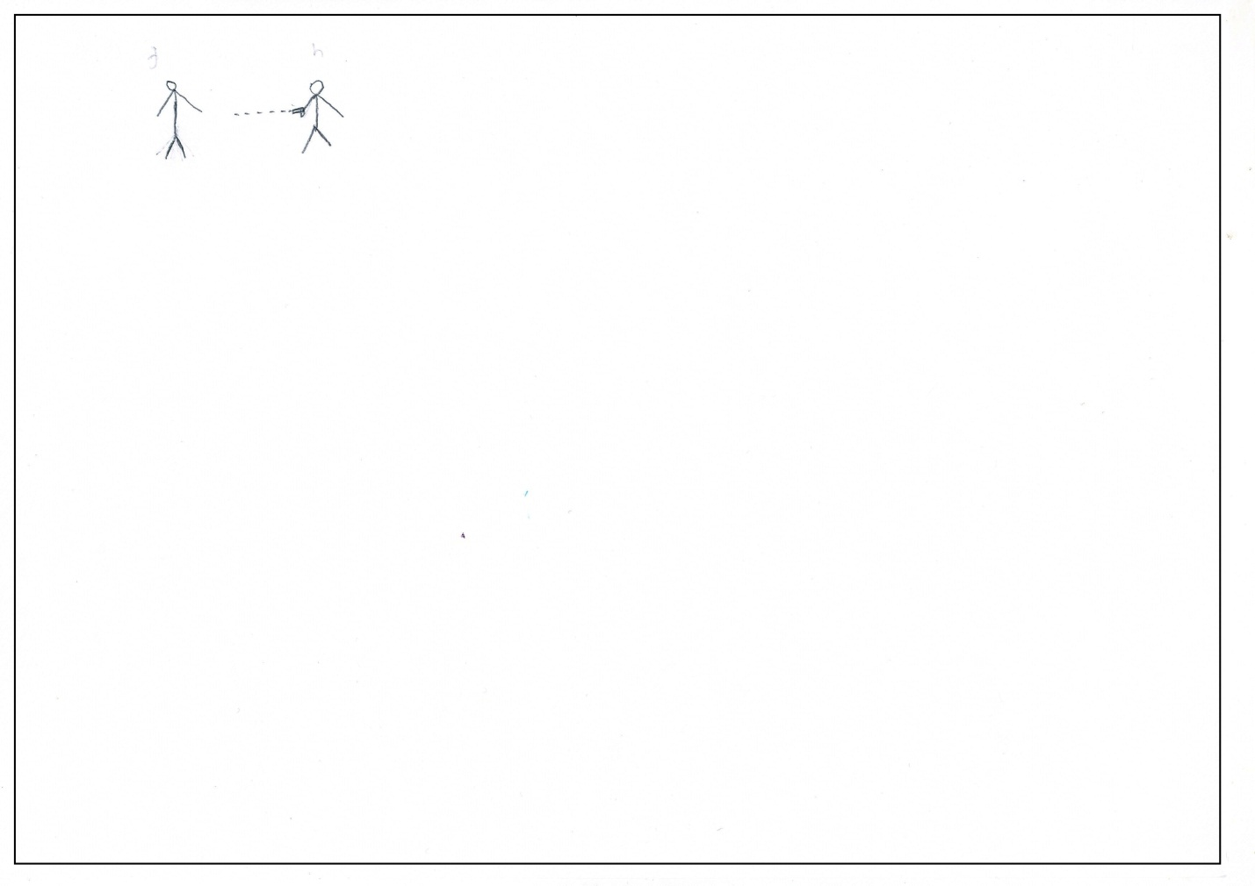

Mariam, 14, IDP

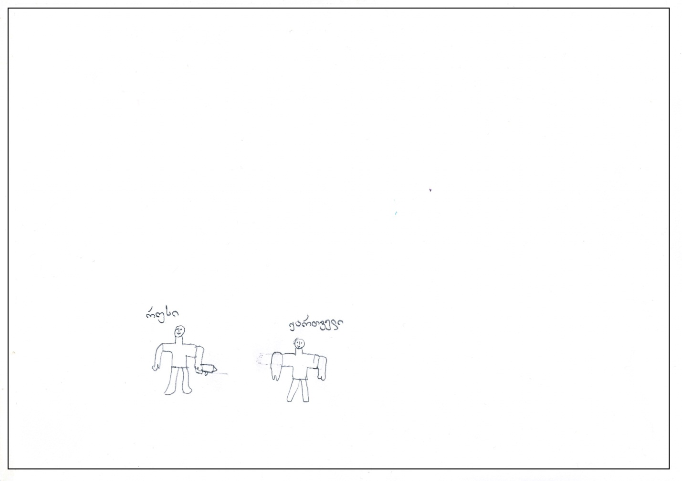

Salome, 13, Tbilisi[11]

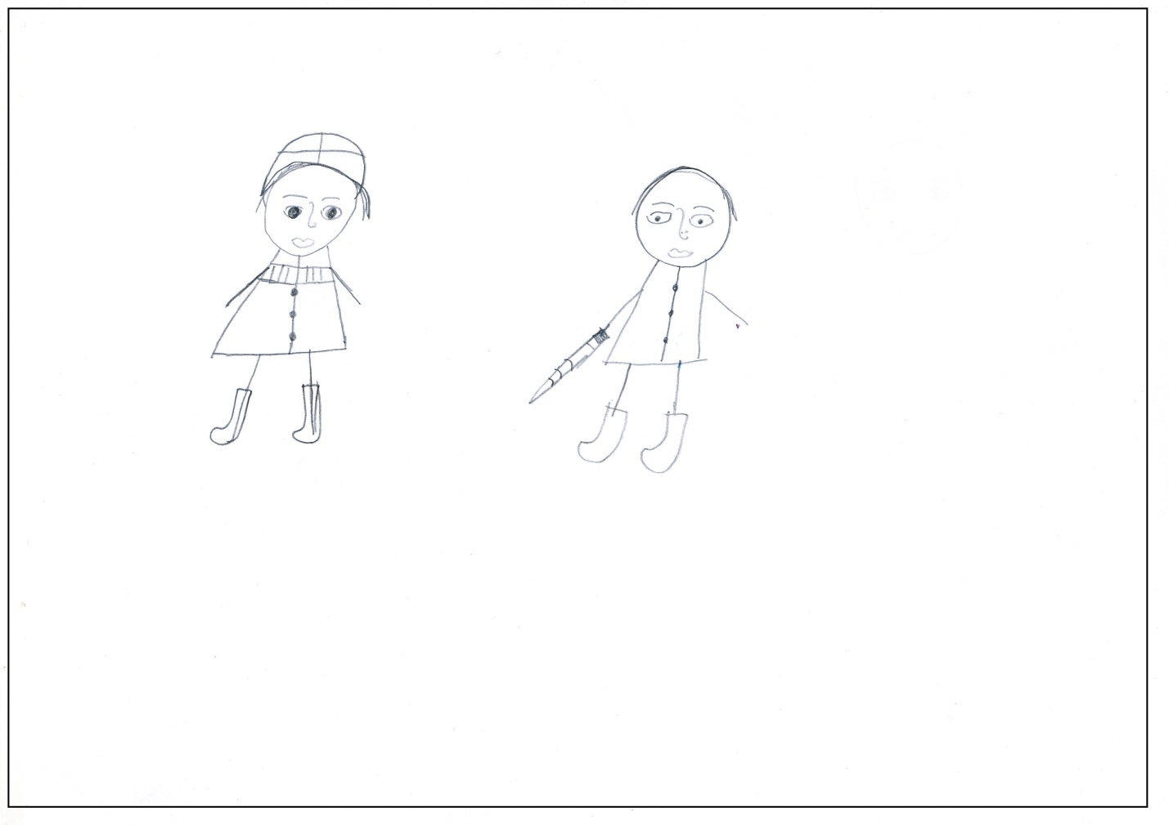

Mary, 13, Tbilisi

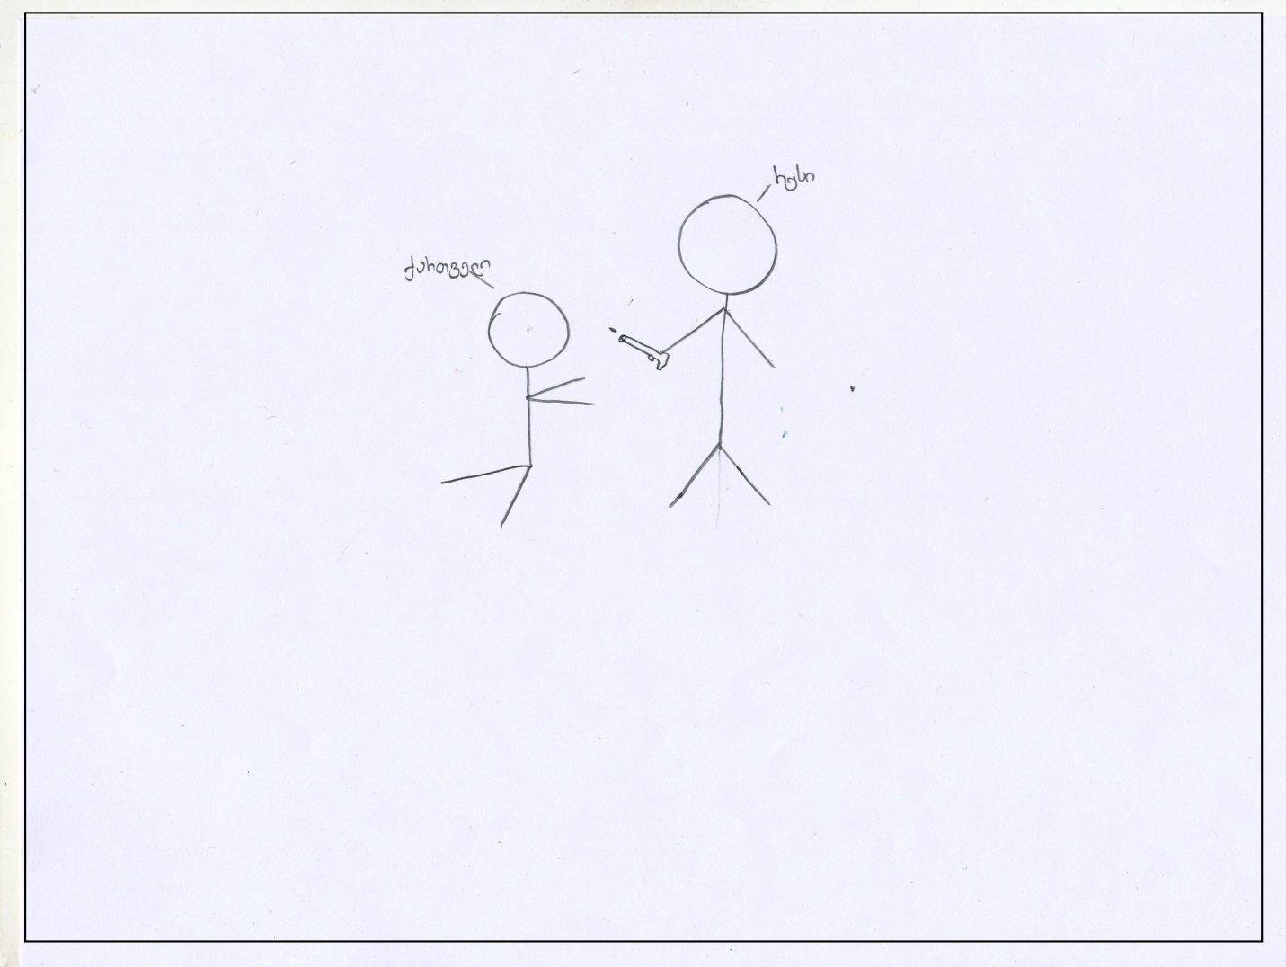

1.2. Russian and Georgian are both aggressive but only Russian is responsible for aggression

Khatia, 12, IDP

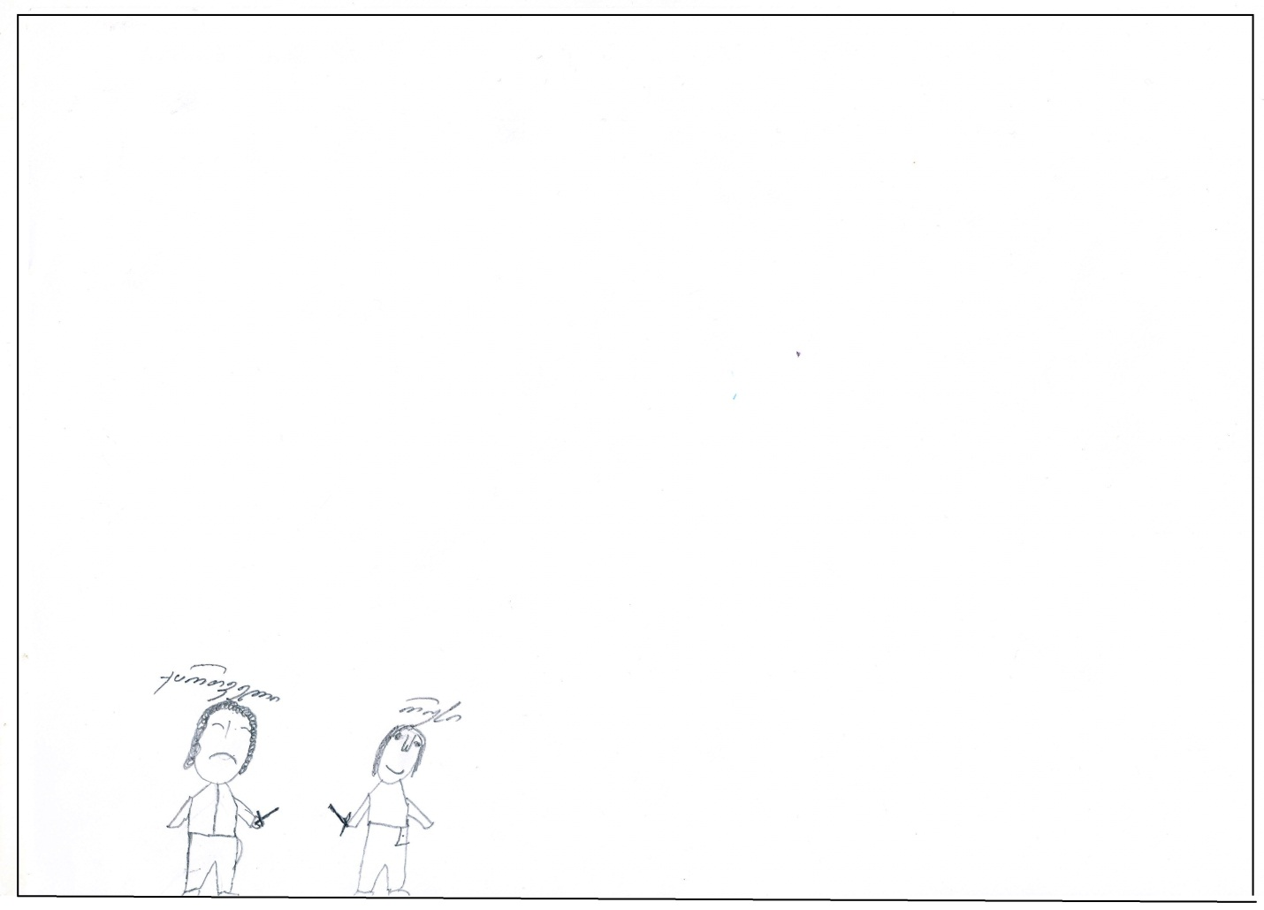

Irakli, 13, IDP

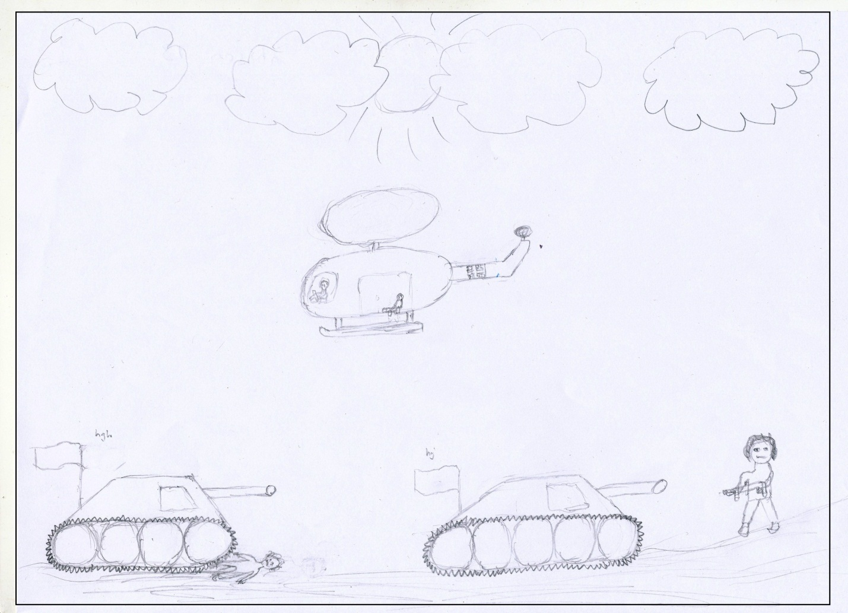

* 1. Russian and Georgian are both aggressive but there is no one to blame.

Paata, 11, IDP

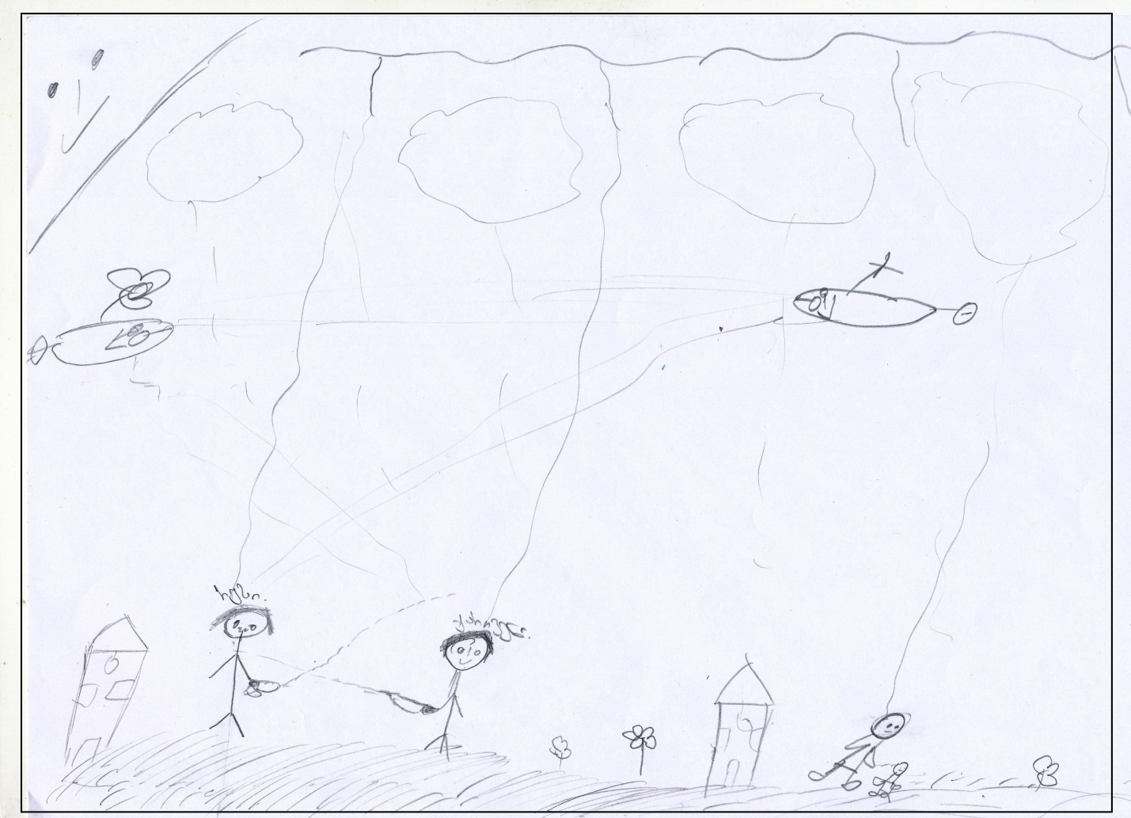

1. **Drawings with non-aggressive content**

2.1 Russian as indifferent person

Nino, 11, IDP

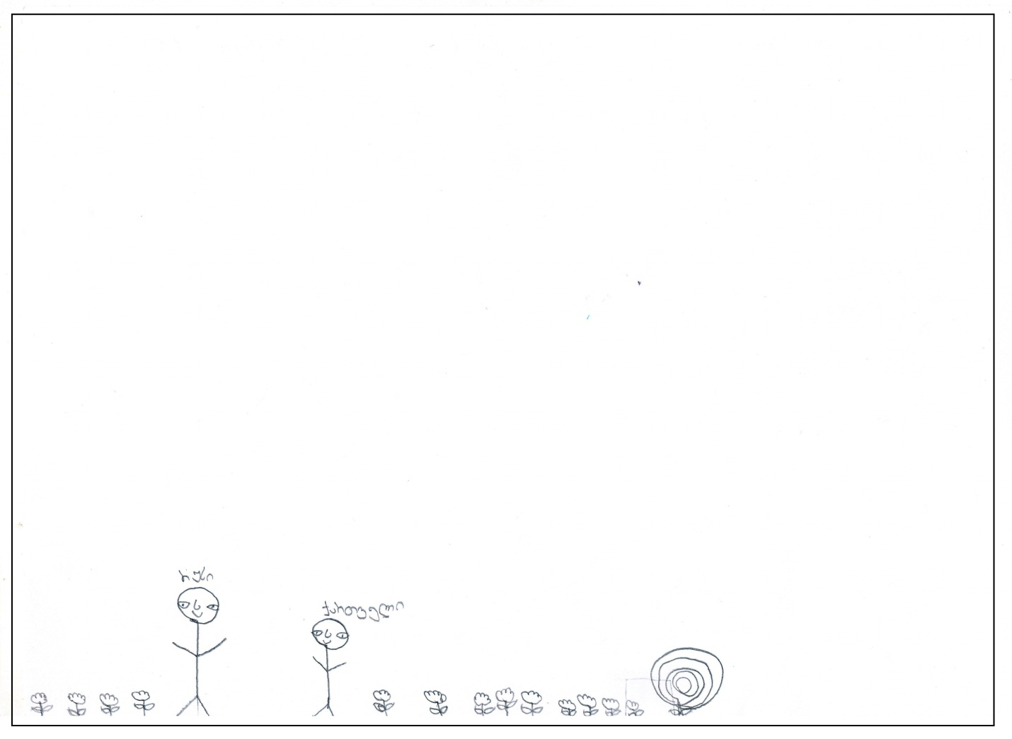

* 1. Russian as positive.

Shota, 13, Tbilisi

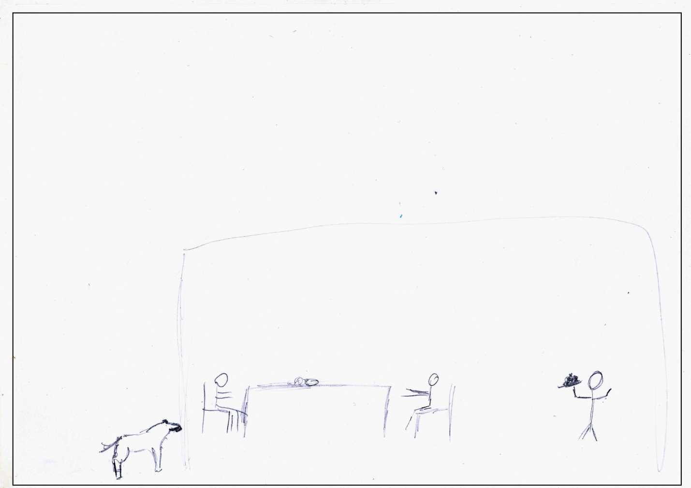

Dato, 13, Tbilisi

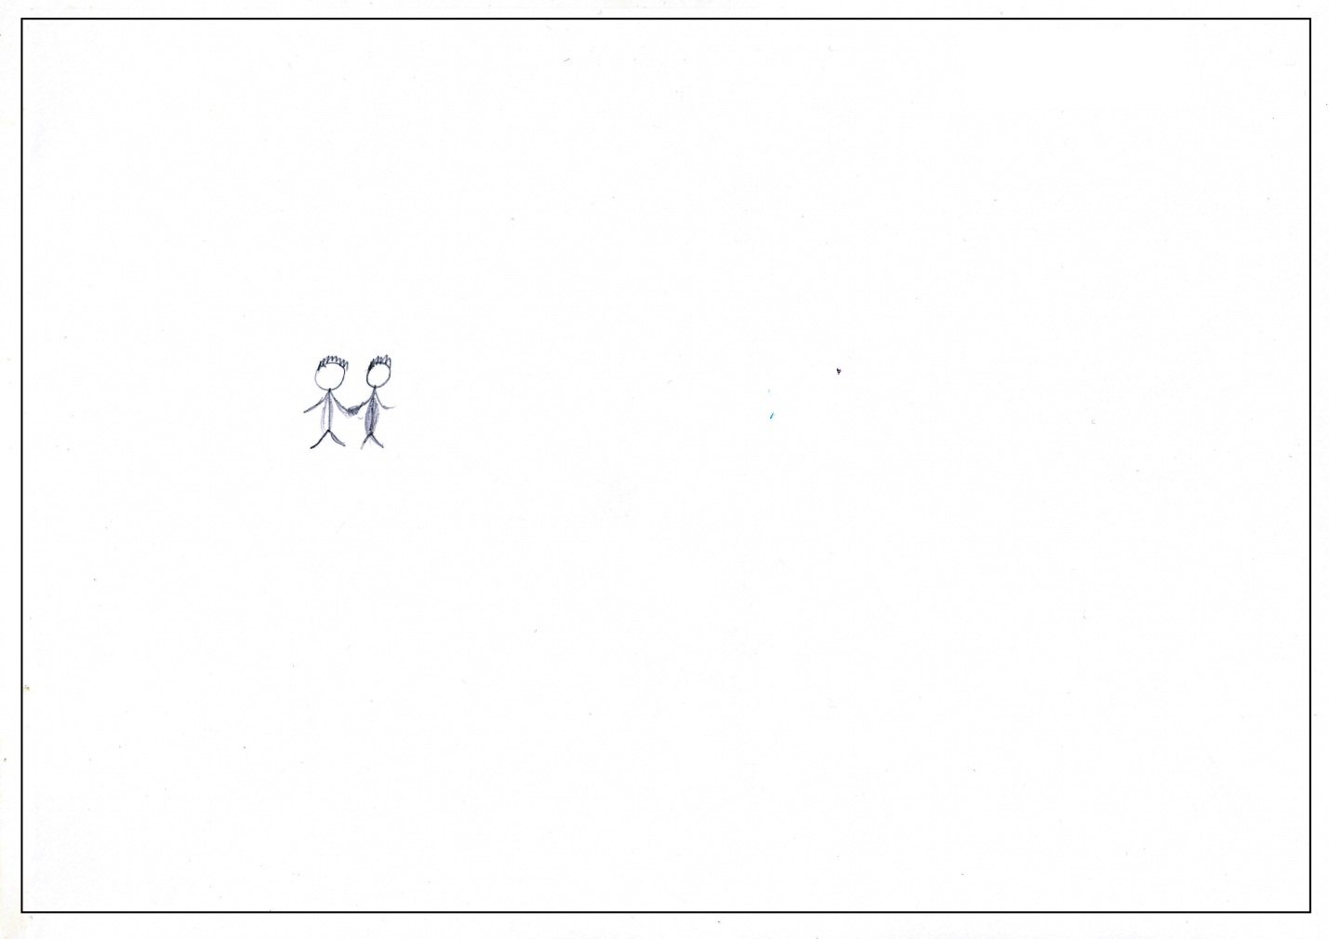

* *Drawing of 10-year old boy from Tserovani Public school*

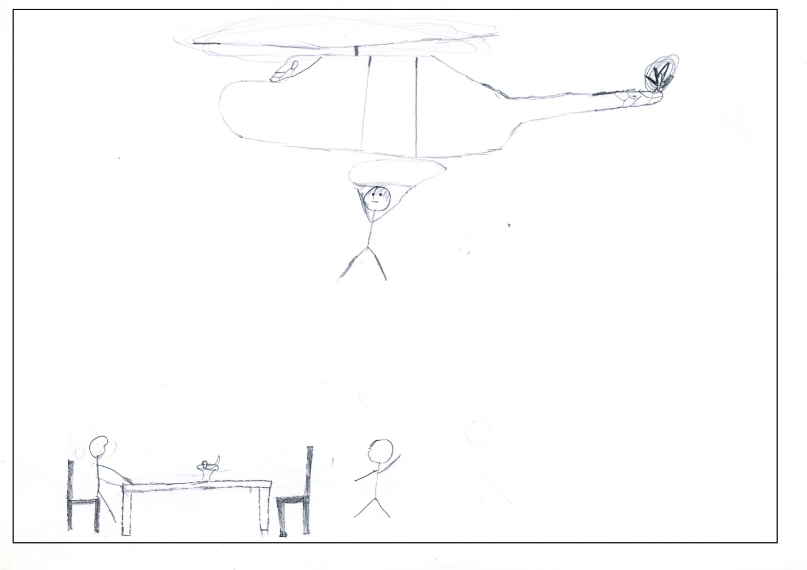

**Appendix 2**

**Interview Transcripts[12]**

**N: 1**

**Name:** Paata

**Age:** 11

**Gender:** male

**Nationality:** Georgian

**Place:** from Conflict zone

**Interviewer:** Can you tell me what you’ve drawn?

**Paata:** Here I drew Russian and Georgian. Russian missed the bullet and Georgian hit him here.

**Interviewer:** Here? In the throat?

**Paata:** *(nods)* These are houses. Here lives Russian *(points at the house near Russian),* here – Georgian *(points at the house near Georgian)* and Georgian’s family is running away and suddenly they fell down in the grass and Georgian called for the plane and Russian called for the plane as well, and now they are shooting vice versa. This is Georgian, Georgian’s plane *(points at plane on the right*). This is Russian’s one *(points at plane on the left)* and then they will… they will shoot and both will explode; and these will die as well, Georgian’s family *(points at Georgian’s family);* and the Russian didn’t have any family.

**Interviewer:** So he was here without family?

**Paata:** Yes.

**Interviewer:** Is it raining or what’s happening?

**Paata:** Yes, it is raining and here is lightning.

**Interviewer:** So will this Georgian die as well? *(I asked because lightning hits down on Georgian and Russian)*

**Paata:** Yes, Georgian will die and this little kid will survive. Mother will die.

**Interviewer:** What about Russian?

**Paata:** Russian will die by himself as Georgian shot him with the bullet.

**Interviewer:** So finally only this kid will survive, Georgian one, right?

**Paata:** Yes.

**Interviewer:** Can you tell me if you know any Russian person?

**Paata:** No.

**Interviewer:** And would you make friends with the one of your own age?

**Paata:** Yes.

**Interviewer:** Can you tell me why?

**Paata:** Because he is little and so… how can I say… I would like to make friends.

**Interviewer:** What it will be like?

**Paata:** If he is the same age as me, I would make friends. If he is the same age as me and my classmate. Otherwise I don’t know…

**Interviewer:** And could you recognize Russian person, for example in the street?

**Paata:** I think I can… they have lighter hair and skin also…

**N: 2**

**Name:** Khatia

**Age:** 12

**Gender:** female

**Nationality:** Georgian

**Place:** from Conflict zone

**Khatia:** *(In the process of drawing talking to herself)* How can I draw a pistol? *(Finally draws sword)* Let’s say they are fighting with swords… I cannot draw a pistol well and…

**Interviewer:** Don’t worry about not drawing well, later you’ll explain what is what and I’ll understand…

*(After she finished drawing)*

**Interviewer:** Can you explain what is happening?

**Khatia:** This is Russian, this is Georgian and they are fighting with swords.

**Interviewer:** Can you write above them who is who?

**Khatia:** Yes.

**Interviewer:** So this is smiling and that is not? *(She wrote Russian above smiling one and Georgian over sad one)*

**Khatia:** yes.

**Interviewer:** So he is happy and that one not?

**Khatia:** …

**Interviewer:** Do you know personally any Russian?

**Khatia:** No

**Interviewer:** Would you make friends with the one? One of your age for example?

**Khatia:** Yes, some of them is good, some - … If a friend is a child, what is his fault then? If there was war, Russians bombed us. It wasn’t a fault of this kid.

**Interviewer:** And could you recognize which one is Russian, for example in the street?

**Khatia:** Well, yes…

**Interviewer:** And can you tell me how?

**Khatia:** They have different appearance, they are whiter… and have small noses… and speak differently…

**N: 3**

**Name:** Tamuna

**Age:** 12

**Gender:** female

**Nationality:** Georgian

**Place:** from Conflict zone

**Interviewer:** *(After she finished drawing)* Can you tell me now what is happening and who is who?

**Tamuna:** This is Russian, Russian policeman. This is Georgian soldier and he is running after him to kill him.

**Interviewer:** So Russian wants to kill Georgian?

**Tamuna:** Yes.

**Interviewer:** Well, do you know anyone Russian?

**Tamuna:** Russian? No.

**Interviewer:** And if you knew would you make friends with one, of your own age? Play with him?

**Tamuna:** Yes.

**Interviewer:** Can you tell me why?

**Tamuna:** I don’t know… For example some Russians are not evil. Some are kind. I would make friends because he concretely hasn’t done any wrong to me.

**Interviewer:** Ok, and can you tell which is Russian if you see?

**Tamuna:** Yes, I can.

**Interviewer:** How?

**Tamuna:** By appearance. They have a bit blonde hair.

**N: 4**

**Name:** Mariam

**Age:** 14

**Gender:** female

**Nationality:** Georgian

**Place:** from Conflict zone

**Mariam:** *(Talking to herself in the process of drawing)* How can I make him hold a gun…

**Interviewer:** Which one do you want to hold the gun?

**Mariam:** I want him *(points at one figure)* to hold a gun and shooting him *(points at another figure)*

**Interviewer:** Well, don’t worry about it… I will understand.

*(After some time)*

**Mariam:** Ummm, I finished.

**Interviewer:** Can you tell me now what’s happening and who is who?

**Mariam:** What’s happening and Russian is shooting Georgian. This is Russian and this is Georgian.

**Interviewer:** Did you want to draw the same here? *(Interviewer points at erased hand of Georgian, because initially it was also drawn raised up exactly like Russian’s hand. She erased it later.)*

**Mariam:** No, initially I wanted this one to be Russian and another one - Georgian and that’s why.

**Interviewer:** Ok, and do you know any Russian personally?

**Mariam:** No.

**Interviewer:** Would you recognize in people which one is Russian?

**Mariam:** Yes.

**Interviewer:** How?

**Mariam:** With nose, they have turned-up noses…

**Interviewer:** So you will understand by appearance…

**Mariam:** Yes.

**Interviewer:** Ok, and would you make friends with Russian? Play together, make friends with one of your own age?

**Mariam:** Don’t know… No…

**Interviewer:** Why?

**Mariam:** Don’t know*… (very long pause*) Maybe because the war had happened and something…

**Interviewer:** So you think they would be aggressive?

**Mariam:** Yes, towards me.

**Interviewer:** And what about you?

**Mariam:** I’m not predisposed towards them so much (*means aggressively or negatively)*

**Interviewer:** So you mean that they will be predisposed towards you, right?

*Here she paused for long time and then I noticed that she was trying to hold tears. When I asked if everything was ok, she started crying. I tried to calm her down, turned off the voice recorder and tried to talk to her.*

**N: 5**

**Name:** Nino

**Age:** 11

**Gender:** female

**Nationality:** Georgian

**Place:** from Conflict zone

*(Explains after she finished drawing)*

**Nino:** Russian man and Georgian were walking in the field; and they met each other; and Russian and Georgian got known to each other; and Russian and Georgian made friends with each other. They had good friendship and were good friends. And Georgian asked Russian that he was interested in why you bombed us, why you made us go away from our homes; and Russian… He didn’t say anything, he was silent and Georgian wanted answer but he wasn’t responding. *(Style is not changed during translation; in Georgian certain things also sound grammatically incorrect)*

**Interviewer:** Ok, and here are flowers in the field, right? And this one? *(points at spiral-like figure)*

**Nino:** That’s rose *(smiles)*

**Interviewer:** Well, and do you know any Russian personally?

**Nino:** No, I don’t.

**Interviewer:** And would you make friends with one if you knew?

**Nino:** I would make friends with Russian, only if he is child and a kind one.

**Interviewer:** And can you recognize which one is Russian?

**Nino:** I don’t know… I don’t think I can... maybe if he appears to be different from Georgians, then I’ll recognize.

**Interviewer:** How different can he be?

**Nino:** Very different with voice, speaking, face as well…

**Interviewer:** What does “different”mean?

**Nino:** I can’t explain… different, different from everybody… For example, Russians do have different character from Georgians, don’t they? Very very very different. It is also true that Georgians are different from each other as well, but… For example, when I was in Kekhvi *(her home-village in conflict zone),* when bombing began, I have seen Russian; different from Georgians…

**Interviewer:** Do you know what I can’t understand? For example this paper and that folder are also different from each other *(shows at paper and folder on the table*), but one can explain how… How different?

**Nino:** With characters too. Georgian as well, but there is an evil Russian and a kind Russian, isn’t it? Georgians are also like that. There are evil ones and kind ones, aren’t they?

**Interviewer:** If there are evil and kind Georgians and there are evil and kind Russians, what do you mean in “difference”then?

**Nino:** I also can’t understand… I would recognize on face… Because I witnessed when they were bombing there. When we were leaving, I witnessed the war… by face and…

**Interviewer:** So you would recognize by face and different character… Worse? Better?

**Nino:** Worse. Because what I witnessed there, they were bombing everything and burning the houses.

**Interviewer:** And if the one would be of your own age?

**Nino:** If he is kind and of my age, of course I would make friends and if he is a good kid.

**Interviewer:** So he can appear to be kind?

**Nino:** Yes.

**Interviewer:** Which one is this on your drawing? Kind or evil?

**Nino:** He is kind and evil at the same time and Georgian is kind.

**N: 6**

**Name:** Irakli

**Age:** 13

**Gender:** male

**Nationality:** Georgian

**Place:** from Conflict zone

**Irakli:** *(In the beginning, immediately after he was asked to draw)* Am I allowed to draw a tank and things like that?

**Interviewer:** You are allowed to draw everything you want.

*He seemed extremely closed and very serious, had been drawing very carefully and in details for about 20 minutes. In the middle he asked:*

**Irakli:** Unfortunately I don’t remember how Russian flag exactly looks like, maybe you remember?

**Interviewer:** It’s ok, you can write above the flag that it is Russian flag.

*After he finished drawing:*

**Irakli:** These are Russian troops *(points at tanks).* This is Georgian. They ran over him with a tank, he is dead. This is one of the Georgians, who resists them *(points at figure on the right)* and this is already Georgian troops who counterattacked*. (points at helicopter)*

**Interviewer:** So Russians are inside tanks, right?

**Irakli:** Yes.

**Interviewer:** Do you know personally any Russian person?

**Irakli:** No.

**Interviewer:** Would you make friends with one? Of your age?

**Irakli:** No. *(He didn’t pause and seemed pretty categorical)*

*I was very afraid to ask further questions to him because of my experience with another girl who seemed closed, introverted as well and then started crying when I tried to get detailed answer.*

**N 7**

**Name:** Salome

**Age:** 13

**Gender:** female

**Nationality:** Georgian

**Place:** Tbilisi

**Interviewer:** Can you tell me now what’s happening here and who is who?

**Salome:** This is Georgian, therefore - peaceful person (*points at left figure*) He is not holding a weapon, he is not holding anything. This is Georgian traditional clothes. Well, this is Russian *(right figure)* and this is sword, or any weapon.

**Interviewer:** So that one is peaceful and this one is not?

**Salome:** Yes, so Georgians are peaceful and they are warmongers.

**Interviewer:** Can you tell me if you know personally any Russian?

**Salome:** No, I don’t know any Russian.

**Interviewer:** If he was of your own age, would you like to make friends with one?

**Salome:** Yes, why not. Children’s fault is nothing, I think so.

**Interviewer:** So child would be peaceful and adult – won’t?

**Salome:** There are some people in Russia who are not peaceful and are warmongers. But there are some people as well who are not warmongers. There are people like this in Georgia as well – warmongers and normal.

**Interviewer:** And can you tell me, if you could recognize who is Russian for example in the street?

**Salome:** Yes, I would recognize on face, because Georgians have more different appearance and Russians – different.

**Interviewer:** How different?

**Salome:** They are more blonde than Georgians… They have absolutely different appearance.

**N 8**

**Name:** Shota

**Age:** 13

**Gender:** male

**Nationality:** Georgian

**Place:** Tbilisi

**Interviewer:** Can you tell me now who is who and what is happening?

**Shota:** So let’s say this is Georgian and let’s say this is Russian and they are feasting. Let’s say this is restaurant.

**Interviewer:** Could you write above figures which one is which?

**Shota:** Ummm… It doesn’t matter. Let’s say here is a wall (*continues drawing at the same time and talking)* So let it be the house and on this side and an animal is waiting for Russian. Here is a servant who serves.

**Interviewer:** Whose house is it, Georgian’s or Russian’s?

**Shota:** Mmm… Let it be Russian’s.

**Interviewer:** “Let it be”, so it doesn’t matter?

**Shota:** Well, no… Why… Let it be, let it be Russian’s.

**Interviewer:** Well, and do you know any Russian personally?

**Shota:** Yes, I have neighbors *(smiles)*

**Interviewer:** And what about friendship, would you make friends?

**Shota:** Yes.

**Interviewer:** Can you recognize who is Russian, for example in the street?

**Shota:** Yes, by appearance.

**Interviewer:** By appearance, how?

**Shota:** Russians are someway different from Georgians by appearance, and they may be different by manner or speaking… *(with lots of pauses)*

**N 9**

**Name:** Mary

**Age:** 13

**Gender:** female

**Nationality:** Georgian

**Place:** Tbilisi

**Interviewer:** Can you tell me now who is who and what is happening?

**Mary:** So he is Georgian *(points at left figure).* He is Russian *(right figure*). He is standing on his knees.

**Interviewer:** Can you write above which one is which? *(writes)*

So the one on his knees is Georgian, right?

**Mary:** Yes.

**Interviewer:** So can you tell me now what’s happening?

**Mary:** This Georgian… Well, this drawing describes war time. This Georgian is standing on his knees and the Russian is shooting him with gun.

**Interviewer:** Ok… And do you know any Russian?

**Mary:** No.

**Interviewer:** And would you like to get known and make friends with one of your age?

**Mary:** No.

**Interviewer:** Can you tell me why?

**Mary:** I don’t know… I don’t like these people generally.

**Interviewer:** Why?

**Mary:** I don’t know… Because towards Georgia they express any possible kind of aggression.

**Interviewer:** Let’s say one of your own age? Would he express as well?

**Mary:** Mmm… It’s not necessarily about people, it’s president’s fault but I don’t know… With one of my age I would make friends.

**Interviewer:** And why would you make friends with one of your own age?

**Mary:** I don’t know… Because he is ordinary child as well… It’s not his fault that Russians are against us. I don’t know… I would make friends with him, but not with other… Not with adult.

**Interviewer:** And would you recognize which one is Russian in people? Let’s say in the street.

**Mary:** I can’t say like this… About some people you can say who is Russian and about others – you may not. About some people it is visible by appearance. Some may have that kind of face or I don’t know…

**Interviewer:** What kind?

**Mary:** I don’t know… That kind of attitude towards person.

**Interviewer:** Whose attitude? Are you talking about Russian’s attitude or yours ?

**Mary:** No, no, his. Russian’s.

**Interviewer:** So he would have an attitude and you can recognize with it, right?

**Mary:** Yes, towards Georgian.

**Interviewer:** What kind of attitude?

**Mary:** For example aggressive.

**N 10**

**Name:** Dato

**Age:** 13

**Gender:** male

**Nationality:** Georgian

**Place:** Tbilisi

*(After he finished drawing)*

**Dato:** I drew about friendship of Russian and Georgian. Russian and Georgian are holding hands.

**Interviewer:** Which one is Russian and which is Georgian?

**Dato:** Well, it doesn’t matter.

**Interviewer:** Ok, do you know someone?

**Dato:** Russian?

**Interviewer:** Yes.

**Dato:** Yes, many of them.

**Interviewer:** And what kind of relations do you have? What are they like?

**Dato:** Very good. Better than some Georgians.

**Interviewer:** So you are friends?

**Dato:** Yes.

**Interviewer:** Well, can you tell which is Russian, for example in the street?

**Dato:** Yes.

**Interviewer:** How?

**Dato:** I understand, they are very different from Georgians.

**Interviewer:** How?

**Dato:** When you look at them, you understand that… majority is more blonde, has lighter skin, you can understand by their speaking as well…

**Appendix 3**

**Application and Response from The Ministry of Education and Science of Georgia**

**(Original and translation)**

საქართველოს განათლებისა და მეცნიერების მინისტრს

ბ-ნ დიმიტრი შაშკინს,

ამავე ქვეყნის მოქალაქის,

ამჟამად ოსლოს უნივერსიტეტის სტუდენტის

ირინე ოსეფაშვილის

გ ა ნ ც ხ ა დ ე ბ ა

ვატარებ კვლევას მაგისტრის ხარისხის მოსაპოვებლად ოსლოს უნივერსიტეტში (UIO) (სპეციალობა - Peace and Conflict Studies). კვლევა ეხება ბავშვების თვალით დანახულ ქართულ-რუსულ ურთიერთობებს. მეთოდად გამოყენებული იქნება მათივე ნახატები. კვლევის ხელმძღვანელები არიან პროფესორები ირენ ლევინი ([irene.levin@hioa.no](mailto:irene.levin@hioa.no)) და კარინ დოკენი (karin.dokken@stv.uio.no). ყოველგვარი ეთიკური ნორმა იქნება დაცული.

გთხოვთ, მომანიჭოთ ხსენებული კვლევისათვის წეროვანის სკოლასა და თბილისის სხვა ქართულ სკოლებში შესვლის უფლება 15 თებერვლიდან 15 მარტამდე.

განმცხადებელი: ირინე ოსეფაშვილი

თარიღი: 26.01.2012

To the Minister of Education and Science of Georgia,

Mr. Dimitri Shashkin

From the citizen of same state,

Currently student of University of Oslo

Irine Osepashvili

APPLICATION

I am conducting a research for Master Degree at the University of Oslo (UIO) (Speciality – Peace and Conflict Studies). The research refers to Russo-Georgian relations seen from the perspective of children. As a method I will use their drawings. Research supervisors are Professors Irene Levin ([irene.levin@hioa.no](mailto:irene.levin@hioa.no)) and Karin Dokken (karin.dokken@stv.uio.no). All ethical standards will be taken into account.

I ask for your permission to conduct this research in Tserovani school and other Georgian schools in Tbilisi from February 15 to March 15.

Applicant: Irine Osepashvili

Date: 26.01.2012

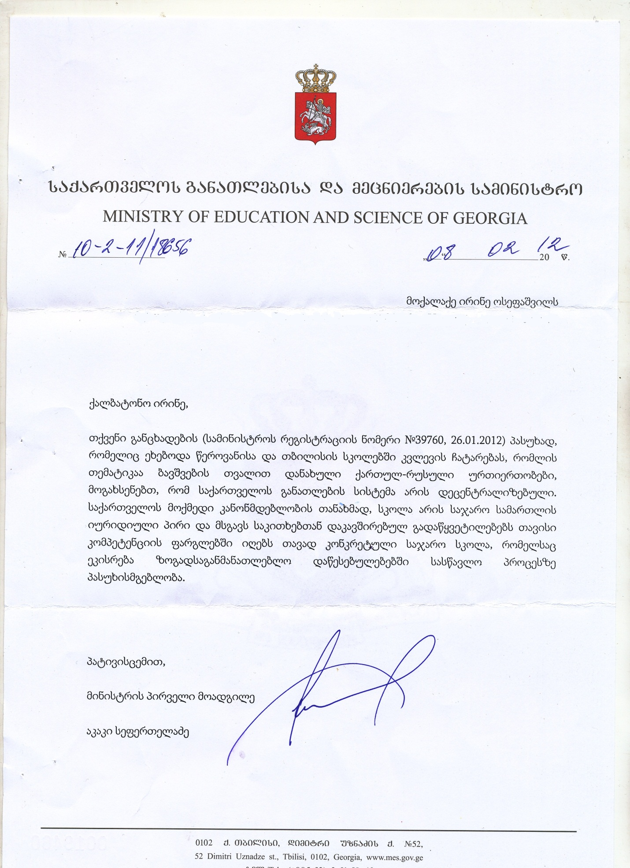

MINISTRY OF EDUCATION AND SCIENCE OF GEORGIA

N10-2-11/18656 08.02.2012

To Citizen Irine Osepashvili

Ms. Irine,

In response to your application (Number of Ministry Registration N39760, 26.01.2012) about conducting research in Tserovani and Tbilisi schools , topic of which has to do with children’s perspective of Russo-Georgian relations, we let you know that educational system of Georgia is decentralized. According to current law of Georgia, school is a juridical personality and particular public school, that is responsible on learning process in educational institutes, makes own decisions regarding similar issues within its competence .

Sincerely,

First Deputy Minister,

Akaki Seperteladze

1. Considered as most traditional enemies of Georgia throughout many centuries
2. Except common religion, Orthodox Christianity, Georgians and Russian differ in race, ethnical origin, language, alphabet, traditions, etc.
3. Capital city of Abkhazia
4. Nesdale basically focuses on ethnic prejudice here.

  
5. At first he defined it as restaurant, but then changed into house
6. From three children who refused to make friends with Russian kid, only two were asked about reason
7. After previous experience I felt anxious not to cause any harm to him as well.
8. Participant numbers in the table correspond to participant numbers in the interview transcript (attached)
9. In Georgian language there is no such thing as gender at all. All words and pronouns are neutral and applicable for both genders. For instance, when the person is speaking about someone you can never tell who they mean, male or female, if they do not want to make it clear themselves. Therefore children were not given any unintentional hint about who they should draw. They were told to draw “Russian” and “Georgian”, which are neutral words. Pronouns they used while describing own drawings are also neutral.
10. In most cases children never stated gender explicitly but I think in war scenes they probably depicted men because female soldiers are not very common in Georgian reality. (Of course women can fight if they want to but it is very rare). Moreover, in case of emergency for all male citizens (with certain restrictions based on age and health condition) it is compulsory to fight the war while women are expected to stay home. Even for the neutral word “soldier” Georgian translation sounds as “army man”. Therefore, I assume that for these children prototype of soldier will be rather male than female.
11. Dress-like clothes/ cap on Georgian figure is traditional Georgian costume for men
12. Original transcript is in Georgian language. As words have no gender in Georgian, in present translation I mostly use “he” for drawn figures. But in actual interview children and I used neutral pronouns (except several occasions when they made it clear themselves, for instance mentioned the word “man”).